|  |
| --- |
|  |
| Swarm Technology – Raspberry PI |
| A Search and Rescue problem |
|  |
| **Alexander Thomas** |
|  |

|  |
| --- |
| *This project looks at the issue of Search and Rescue and Swarm Technology. Think of a situation where you could be lost, such as collapsed mine or lost in a forest. Current methods of finding you rely on brute force, as a result, they can be costly and require lots of manpower. But can these drawbacks be solved by using swarm robotics?* |

# Abstract

This project looks at the issue of Search and Rescue and Swarm Technology. Think of a situation where you could be lost, such as a collapsed mine or lost in a forest. Current methods of finding you rely on brute force, as a result, they can be time consuming and require lots of manpower. But can these drawbacks be solved by using swarm robotics?

My idea is to build 4 Raspberry Pi robots and attempt to make them simulate swarm behaviour using multiple RaspiRobot. A RaspiRobot is a remote controlled car, powered by a Raspberry Pi (a credit card–sized single-board computer). The reason for deciding to use Raspberry Pi is because they offer many open source software and can have endless possibilities to build upon. The end goal is to have multiple robots communicating with each other and working together to solve simplified Search and Rescue problems.

Swarm intelligence fits well because each robot will be a self-organised system/agent and will be able to follow 'basic' rules. Swarm robotics is a rapidly growing field and my findings will put into practice many theorised ideas.

Keywords: Artificial intelligence (AI), swarm technology, Raspberry Pi, Search and rescuers

# Acknowledgement

I would like to express my thanks to my project supervisor Dr Gordon Downie, who supported and pushed me through the project and without his guidance I would have never finished.

Secondly, I would also like to thank my Dad and friends who supported me and kept me motivated.

Lastly, I would like to state my greatest appreciation to those no longer with us, as without them none of this would be possible.

# Table of Contents

Abstract 1

Acknowledgement 2

Table of Contents 3

Table of Figures 7

Table of Equations 8

Table of Tables 8

1 Introduction 1-10

1.1 Report Structure 1-11

2 Background Research 2-13

2.1 Introduction 2-13

2.2 What is intelligence 2-13

2.3 Swarm intelligence 2-14

2.3.1 Swarm optimization 2-15

2.4 Particle swarm optimization 2-18

2.5 Subsumption 2-19

2.6 Application of Swarm intelligence 2-21

2.7 Search and rescuers 2-24

2.7.1 Application of Swarm intelligence relating to Search and rescuers 2-27

2.8 Raspberry Pi 2-28

2.8.1 Pi2go 2-29

2.9 Summary 2-30

3 Requirements and Analysis 3-32

3.1 Introduction 3-32

3.2 Hypothesis 3-32

3.3 Aim and Objective 3-32

3.3.1 Aim 3-33

3.3.2 Objective 3-33

3.4 Development Methodology 3-34

3.5 Search and rescue 3-35

3.6 UML Use case 3-36

3.7 Functional requirements 3-37

3.8 Non-functional requirements 3-38

3.9 MosCoW Prioritization 3-39

3.10 Tools 3-41

3.10.1 Hardware: 3-41

3.10.2 Software: 3-41

3.11 Risk Management 3-41

3.11.1 Project Risks 3-44

3.11.2 Hardware Risk 3-45

3.11.3 Software Risk 3-47

4 Design 4-49

4.1 Introduction 4-49

4.2 Hardware 4-50

4.3 Class Identification 4-52

4.4 Class relationship 4-55

4.5 System interaction 4-57

4.6 Pseudo code 4-58

4.6.1 Main 4-59

4.6.2 Left and Right 4-59

4.6.3 Front 4-60

4.6.4 Update history 4-61

4.6.5 Goal state 4-62

4.6.6 Sender 4-63

4.6.7 Receive 4-63

4.7 Rapid prototyping 4-64

4.7.1 Prerequisite 4-64

4.7.2 Stage One 4-65

4.7.3 Stage Two 4-66

4.7.4 Stage Three 4-67

4.8 Project tine 4-68

5 Implementation 5-69

5.1 Introduction 5-69

5.1.1 Prerequisite 5-69

5.1.2 Issues encountered 5-71

5.2 First prototype 5-71

5.2.1 Check left method 5-71

5.2.2 Check right method 5-72

5.2.3 Check front method 5-72

5.2.4 Goal state method 5-73

5.2.5 Issues encountered 5-74

5.3 Second prototype 5-74

5.3.1 Communication class 5-75

5.3.2 Update method 5-77

5.4 Third prototype 5-78

6 Testing 6-81

6.1 Functional requirements testing 6-81

6.2 Non-Functional requirements testing 6-85

7 Conclusion 7-89

7.1 Introduction 7-89

7.2 Reflection 7-89

7.2.1 Reflection on Research 7-89

7.2.2 Reflection on Requirements and Analysis 7-90

7.2.3 Reflection on Design 7-91

7.2.4 Reflection on Implementation 7-92

7.2.5 Reflection on Testing 7-93

7.3 Future Work 7-94

7.4 Closing Statement 7-94

8 Glossary 8-96

References 97

# Table of Figures

Figure 1: Grand Canyon national park search and rescue report 1-11

Figure 2: Separation example 2-17

Figure 3: Alignment example 2-17

Figure 4: Cohesion example 2-18

Figure 5: Subsumption architecture 2-21

Figure 6: State based architecture 2-21

Figure 7: CARACaS architecture 2-24

Figure 8: Search and Rescue, UK and Overseas Callout, Incidents and Persons Moved 2-25

Figure 9: Prototypes Design Process 3-36

Figure 10: UML Use case diagram 3-38

Figure 11: State flow diagram 3-39

Figure 12: Hardware Schematic 4-50

Figure 13: Simple class diagram 4-55

Figure 14: Middleware class diagram 4-56

Figure 15: Action class diagram 4-56

Figure 16: Communication class diagram 4-57

Figure 17: UML sequence diagram 4-58

Figure 18: Gantt chart 4-68

Figure 19: 'sudo i2cdetect -y 1' Command 5-70

Figure 20: SSH connection 5-74

Figure 21: SAR based subsumption architecture 5-80

# Table of Equations

Equation 1: Particle Swarm 2-18

# Table of Tables

Table 1: Chapter breakdown 12

Table 2: MosCoW Task Prioritisation 3-40

Table 3: Risk Management consequence & Score 3-42

Table 4: Project Risks 3-44

Table 5: Hardware Risk 3-45

Table 6: Software Risks 3-47

Table 7: Overview of Hardware 4-51

Table 8: Class-responsibility- collaborate cards – MiddleWare 4-52

Table 9: Class-responsibility- collaborate cards - Adafruit_PWM_Servo_Driver 4-52

Table 10: Class-responsibility-collaborate cards - Action 4-53

Table 11: Class-responsibility-collaborate cards - Communication 4-53

Table 12: Rapid Prototyping – prerequisite 4-64

Table 13: Rapid Prototyping - Stage One 4-64

Table 14: Rapid Prototyping - Stage Two 4-65

Table 15: Rapid Prototyping - Stage Three 4-66

Table 16: Functional requirements testing - Use case diagram 6-80

Table 17: Functional requirements testing - Avoid objects left 6-81

Table 18: Functional requirements testing - Avoid objects right 6-81

Table 19: Functional requirements testing - Avoid objects front 6-82

Table 20: Functional requirements testing - Movement 6-82

Table 21: Functional requirements testing - Goal state 6-82

Table 22: Functional requirements testing - Communication 6-83

Table 23: Functional requirements testing - Flow diagram 6-83

Table 24: Functional requirements testing - SAR subsumption architecture 6-84

Table 25: Non-functional requirements testing – Scalability 6-85

Table 26: Non-functional requirements testing – Reliability 6-85

Table 27: Non-functional requirements testing – Environmental 6-86

Table 28: Non-functional requirements testing - Well-Documented 6-87

Table 29: Non-functional requirements testing - Open source 6-87

# Introduction

The aim and objectives of all search and rescue missions is to rescue trapped or lost survivors after a natural or man-made disaster. These tasks can be carried out by volunteers or experts, depending on the situation. For example, experts would be deployed when looking for survivors in a nuclear power station leak, whilst volunteers would help look for someone lost in a local park.

Search and rescue is a very large issue, as a result, most country runs 24 hours a day, seven days a week, 365 days a year service. For example, in the Grand Canyon national park, please see Figure 1, on average they experiences 432 incidents each year. Each call out could be a life or death situation, so rescuer must act quickly and safely to ensure they find the missing person as soon as possible. (Ribokas, 1994)

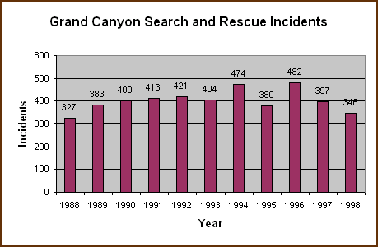

Figure 1: Grand Canyon national park search and rescue report

By extracting search and rescue knowledge and applying it to robots would they be able to compete vs. a human searcher? By applying this knowledge to multiple robots would they be able to solve commonly complex problem following swarm technology principles. Finally would this system consisting of multiple agents act and be conceded ‘intelligent’?

My idea is to build 4 Raspberry Pi robots and attempt to make them simulate swarm behaviour. A RaspiRobot is a remote controlled car, powered by a Raspberry Pi (a credit card–sized single-board computer). The reasons for deciding to use Raspberry Pi is because they offer many open source software and can have endless possibilities to build upon. The end goal is to have multiple robots communicating with each other and working together to solve simplified Search and Rescue problems.

Swarm intelligence fits well because each robot will be a self-organised system/agent and will be able to follow 'basic' rules. Each robot represents an expert in the field and by working together with other robots they should be able find the missing person. Swarm robotics is a rapidly growing field and my findings will put into practice many theorised ideas.

## Report Structure

This report consists of seven chapters, each chapter forces on different section of the project, Please see Table 1 for the breakdown of each chapter.

|  |  |
| --- | --- |
| Chapter | Description |
| Introduction | Chapter 1 outlines the report and the core problem I will attempt to tackle. |
| Background Research | Chapter 2 looks at current method used in search and rescue and swarm intelligence methodises. Its sole purpose is to understand what has come before and infuses my ideas. |
| Requirements and Analysis | Chapter 3 outlines and describes the requirements and scope of the system, via the S.M.A.R.T system. It will draw heavily and be influence by chapter 2. |
| Design | Chapter 4 deliberates the design of the system using standard industry methods, such as rapid prototype and UML |
| Implementation | Chapter 5 gives a detailed step-by-step guide how I implemented and built the designed system. |
| Testing | Chapter 6 describes the test specification for the project. Each test draws up items discussed in chapter 2 and chapter 3. |
| Conclusion | Chapter 7 evaluates and reflect upon the whole process, this critical view will attempt to answer ‘is the system suitable for search and rescue’. In addition, it suggests future development that could be made. |

Table 1: Chapter breakdown

# Background Research

## Introduction

The aim of this literature review is to understand what previous topics and fields have been explored and documented, with reference to AI with a focus on swarm technology. We will first discuss what and how we view intelligence. Following this we will look at how swarm intelligence challenges these viewpoints, with some case studies. We will also look at how swarm intelligence has been and can be applied to search and rescue. This report will include a range of different sources and opposing viewpoints, the reason for this is to better understand the topic. The purpose of this literature review is to:

* Placing my study in an historical perspective, thus avoiding unnecessary duplication
* To evaluate other research methods and understand their concepts

## What is intelligence

Without knowing you may use many different types of AI techniques in a single day, for example Google, Computer games and even Cars. These are all examples of where Artificial intelligence has been applied. Artificial intelligence commonly shortened to AI, is the science, engineering and art of making intelligent machines.

Public opinion and many Hollywood films see AI as creating something or someone with equal human intelligence. This idealised concept tallies, to Alan Turing’s views. If a machine can pass the Turing test we can say it has proven its own intelligences; the test requiring a machine to show intelligent behaviour equivalent to that of a human. He proposed that a human would have a natural language conversation to two monitors, behind one monitor a human and being the other a computer. If he is not able to tell the different between the two, the machine can be classed as intelligent. (Turing, 1950)

This idea of a human machine has been something many have theorized, but this idea is more science fiction than reality. The Chinese room tests put forward by the philosopher John Searle, says “I am locked in a room and I know no Chinese. Questions are passed into the box in Chinese and I’m expected outputs back in English. Within this box I have a full set of Chinese symbols to English words. With this knowledge I can match all inputs and provide a correct output. I still do not understand Chinese, but for any outside the box it appears I understand Chinese.” From this simple reasoning he says no program can be intelligent as it does not understand or is conscious of what it is doing, only self-aware being are capable of being intelligent. Between these two differing viewpoints we cannot define intelligence, but we say if something appears intelligent. (Searle, 1980)

From John Searle’s test he says no program can be intelligent as it does not understand or is conscious of what it is doing, only self-aware being are capable of being intelligent. Rather than basing intelligence on humans, it appears that by observing other animals we can discover different methods and approaches. Intelligence cannot be measured by a high QI or recalling PI to X number of places bur rather how something or someone, whether it be electronic or biological, can ‘learn’ from experience and appear to be intelligent. The area of Artificial intelligence this report will examine is Swarm intelligence, commonly sorted to SI.

## Swarm intelligence

Swarm intelligence is a natural phenomenon in which intelligence can viewed as a collective behaviour of decentralized, dumb self-organized systems with no central control; rather than John Searle’s and Alan Turing’s concept of a central being, e.g. A human brain. Swarm intelligence focuses on simple agents interacting locally with one another within their environment. Each agent follows simple rules with no centralized control structure. These agents are self-organised, autonomous and act locally on their own. However, it can be noted that they can interact with other agents, this cooperation is commonly seen as ‘social interaction’. This method of swarming dumb agent can lead to an emergence of intelligent global behaviour, however, each agent has no concept of the larger problem they are trying to solve.

Humans have discovered and been inspired by nature, especially biological systems. We can clearly see other animals acting intelligently in swarms, for example ant colonies, bird flocking, fish schooling and microbial intelligence to name a few. These natural behaviours can be applied in principle to robots, this concept is called swarm robotics, whiles ‘swarm intelligence' refers to the more general set of algorithms it can employ. The reason why we use swarm algorithms is to try to capture these desirable qualities, such as scalability and being adaptable to changes in their environments, by distributing computation among the agents we see ‘intelligence’ emerging from their actions.

There are many different types of interpretation of swarm intelligence, thus there are subtopics within this field. To name just a few:

* Ant colony optimization
* Artificial immune systems
* Particle swarm optimization

### Swarm optimization

Swarm Intelligence was first introduced by Gerardo Beni and Jing Wang in 1989 within their paper ‘Swarm Intelligence in Cellular Robotic Systems’. Their paper details their viewpoint of intelligence; they define ’intelligent’ behaviour as “unpredictability of improbable behavior” with its concept consisting of:

1. Statistical unpredictability
2. Inaccessibility
3. UN-decidability,
4. Intractability
5. Non-representability

They also noted swarms display emergence and stigmergy characteristic. They were able to analyse this by using positive/negative feedback, amplification of fluctuation and multiple interactions. Furthermore, they observed that these insects are almost blind and memoryless. In relation to swarm robotics they define each part of what makes up an agent. First the machine (the robotic parts) and automation (the behaviour). This allows them to distance ‘body from mind’ and focus on the underlining intelligence of these systems. They also noted the environment depicts their perception of the world around them thus their actions. (Gerardo Beni, 1993)

One of the first artificial simulation of swarm behavior was developed by Craig Reynolds in 1986. This artificial life program was called ‘Boid’, its aim was to simulate and mimic the flocking/swarm behavior of birds. Boid is the name he gave to the bird-like object within the swarm, commonly now referred to as agents in similar programs. His artificial life simulations is one of the first example of emergent behavior.

He identified three key composes that are key to build and govern a boid/agent they are follows:

* **Separation**: avoid other agents

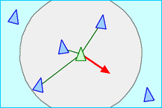

Figure 2: Separation example

* **Alignment**: navigation towards other biods

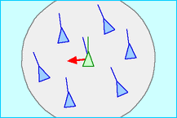

Figure 3: Alignment example

* **Cohesion**: navigation toward the center of mass (other boids)

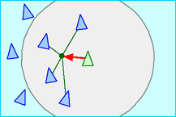

Figure 4: Cohesion example

An example of emergent behavior that follows these core ideas is how the flock can split around an obstacle then rejoin on the other side. Each boid is not aware what they are doing, but together they can be considered emergent behavior. The movement of boid can vary between chaotic (splitting groups and wild iritic behavior) or orderly. This behavior depends on the program's attributes and the goal state. Reynold's approach outlined an this older traditional technique applied to computer animation, as a result further research has added new components for example object avoidance and goal seeking; all build atop of his three main composes. (Reynolds, 1987) (Reynolds, 2001)

## Particle swarm optimization

Particle swarm optimization, shorten to PSO, share many attributes with evolutionary computation techniques. It is a population-based stochastic approach for solving continuous and discrete optimization problems. This technique is an attempt to capture many sort after aspects of swarm intelligence.

In keeping with dumb agents the particle knows two things, its velocity and its personal best result (fitness value) so far. The system starts with ‘x’ population, each particle (agent / biods) is a transferrable random solution within the environment that searches for the optimum or goal state. Each agent could be viewed as a single bird within a flock. Each agent actions should follow the boid model. Due to the agent knowing its own location and fitness, we call this pBest, and the coordinates and fitness of those around, called lbest, it can calculate the ‘best’ action to take. The ‘best’ movement is decided using:

$$v\left[ \right]=v\left[ \right]+learning rate*random number*\left( pbest\left[ \right]-Present \left[ \right] \right)+ learning rate*\left( lbest\left[ \right]-present\left[ \right] \right)$$

$$present\left[ \right]=present+V\left[ \right]$$

Equation 1: Particle Swarm

* v[] = particle/agents velocity
* Persent[] is the current particle’s location
* pbest[] and gbest[] are defined as stated before.
* The learning rate is the rate the program learns, sometimes called the constant weights
* Random Number is a random number between (0, 1).

Particle swarm optimization is appealing because it requires few parameters and it can be applied to any application, including search and rescue. The amount of agents that can be utilised is an open question, is the agents are physical they can be expense due to hardware. If the agents are simulation theoretically it can be unlimited, but too many agents the program may become slow, too little and they might not find the optimum or goal state in a reasonably amount of time.

(Hu, 2006)

## Subsumption

Moshe Sipper says “Life is so diverse and complex that is seems impossible to extract the general principles governing each individual living system”, within ‘An Introduction to Artificial Life’ (Sipper, 1995) he reference Craig Reynolds work saying it underpins the consent of artificial life. He compares the 3 functions (Separation, alignment and cohesion), to a hierarchy of layers, each layer performing a more complex function than the one underneath. The higher layers can subsume the role of lower levels by suppressing or warping their outputs.

Subsumption architecture is behaviour-based approach to robotics that a focus on ‘states’ a robot can be in at a given time. This architecture was designed by Rodney Brooks and detailed within ‘Planning is just a way of avoiding figuring out what to do next’, (Brooks, 1991). This architecture is now being widely utilised by many autonomous systems. Please see Figure 5 for an illustration of a subsumption architecture. From this diagram you can see the many different layers/levels and how they effect of the hierarchy. Figure 6 displays the older classic more simplistic approach of ‘sense-plan-react systems’.

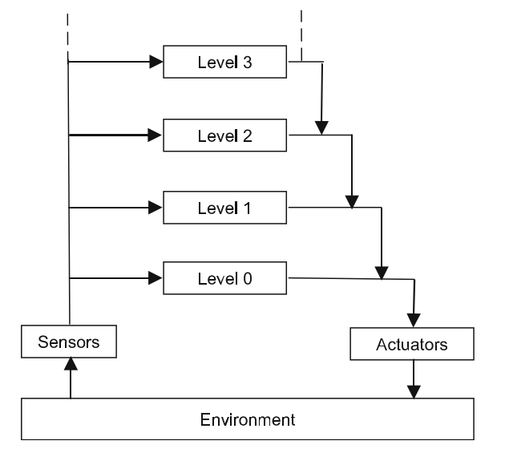

Figure 5: Subsumption architecture

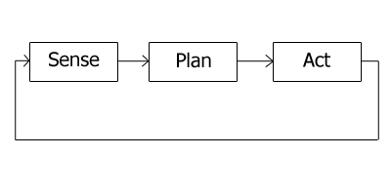

Figure 6: State based architecture

Brook’s method and approach for design sophisticated robots is based around bottom-up methodology rather than typical top-down methodology, as detailed in his paper ‘Elephants Don't Play Chess’. Where he suggests in a humorous way that elephants, like humans, are intelligent, but elephants cannot play chess, but they are able to survive in harsh dynamic environments. Building an AI to solve a goal using top-down methodology, for example Search and rescuer or chess, is very complex and is impossible to identify all possible states. Using a bottom-up approach he states that it allows developers to identify each element, therefore you can gradually build upon ‘simple’ concepts to create a complex idea.

The bois model has strong links to Subsumption and artificial life as it roughly resembles our own brains, for example Separation could be seen as breathing, whilst alignment could be eating and cohesion could be talking. This viewpoint fits into Marvin Minskv's, outlined within ‘The Society of Mind’, (Minsky, 1999) as he views humans brain’s intelligent as an ensemble of agents.

## Application of Swarm intelligence

The boids model has been used in the design for many applications, for example ‘Unmanned Ground Vehicles’ (UGV) and ‘Micro Aerial Vehicles’ (MAV). A case of Unmanned Ground Vehicles is ‘Control Architecture for Robotic Agent Command and Sensing’ (CARACaS). This system aims to control a single autonomous robotic vehicle or multiple cooperating but otherwise autonomous robotic vehicles. It has many applications ranging from spaceships, underwater crafts to land vehicles. One real life example is its use in the U.S. Navy, where they are currently testing "drone" boats. They aim to develop robot boats into mimicking "guard dogs”, which could circle around their warships to detect threats, rather than risk human lives. Each boat is totally autonomous, in keeping with swarm intelligence concepts that intelligence can be a collective behaviour of decentralized, self-organized systems with no central control. If an offensive action would be taken the fire control is human controlled, thus removing fears of blame on the software and its designers. (Lendon, 2014)

The original use for CARACaS was NASA's Mars rover. CARACaS consist of thee coupled agents: a dynamic planning engine, a behaviour engine, and a perception engine. The system follows the multi-agent control architecture design set forward in “An Architecture for Controlling Multiple Robots”, by splitting the system in three parts it easier to manage and modify. Furthermore, it allows for deterministic reaction to the robots ever changing environment or goal state. Within the behaviour engine it uses multi-objective decision theory, as this allows the robot to fit access and choice a pre-set decision based on the current environment. Thus, all behaviour contributes simultaneously to the control of the robot in a cooperative rather than a competitive manner. Thus, all actions are guaranteed to be “good enough” in an ever changing complex environment. When given an input the system tries to satisfy as many goals as possible while still obeying its pre-set decisions. Each pre-set decision is dynamically updated based on when and where it is used, to update these rules the robot uses heuristic, iterative repair approach to producing and modifying actions. These systems, when applied to multiple robots, similar to the U.S. Navy it can simulate Swarm intelligence. (Tech Briefs, 2008) Figure 7 shows the layout and design of their system:

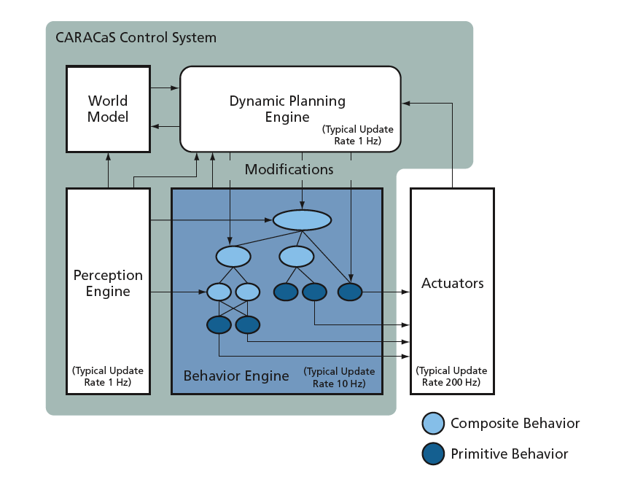

Figure 7: CARACaS architecture

A non-physical / virtual example of swarm intelligence is detailed by Frederick Ducatelle, Gianni A. Di Caro and Luca M. Gambardella in ‘Principles and applications of swarm intelligence for adaptive routing in telecommunications networks’. They aimed to incorporate swarm intelligence to current working telecommunications networks with the objective to improve its performance. From their research they found many different swarm algorithms, similar to my own research, capable of complete their task, but identifying the ‘best’ was more difficult as each methods is different in approach. They found by giving a detailed description of the challenges in this problem domain, they were able to “identify typical building blocks of swarm intelligence systems” to fit their problem. (Frederick Ducatelle, 2010).

## Search and rescuers

Search and rescue, shortened to SAR, in the dictionary is defined as “the activity of looking for and rescuing people who are lost or in danger” (Collins, 1819). Search and rescue cover a wide range of issue, each type of rescue is typically determined by the type of terrain the search is conducted over, for example mountain rescue, ground search and rescue, air-sea rescue to name just a few. Within each field, there can be many different subtopics, for instance a ground search can be urban or rural, perhaps a broken hazardous power station or a large farmer’s field.

The objective for all search and rescue missions is to quickly respond to a lost person / people incident. The faster they can react the sooner they can locate the victim, thus improving their chances of survival. On September the 11th, 2001 terrorists collapsed the Twin Towers in New York City with two commercial jets, thus instigating the largest SAR mission in U.S history. 2,996 people were killed, and over 6,000 people injured. 411 emergency workers died trying to rescue people and fight fires, more often than not each incident puts rescuers in danger. Figure Figure 8 shows the large scale of SAR happening every year within the UK and its oversea provinces (Cyprus and Falkland Islands). Please note this only includes RAF and Royal Navy searches, and not missing person’s cases. Each time an SAR unit attending an ‘incident’ is described as a ‘callout’; with some incident resulting in more the one callout. ‘People moved’ is where people were rescued. Please note this data does not show failed investigation or fatal incidents. (Ministry of Defence, 2016)

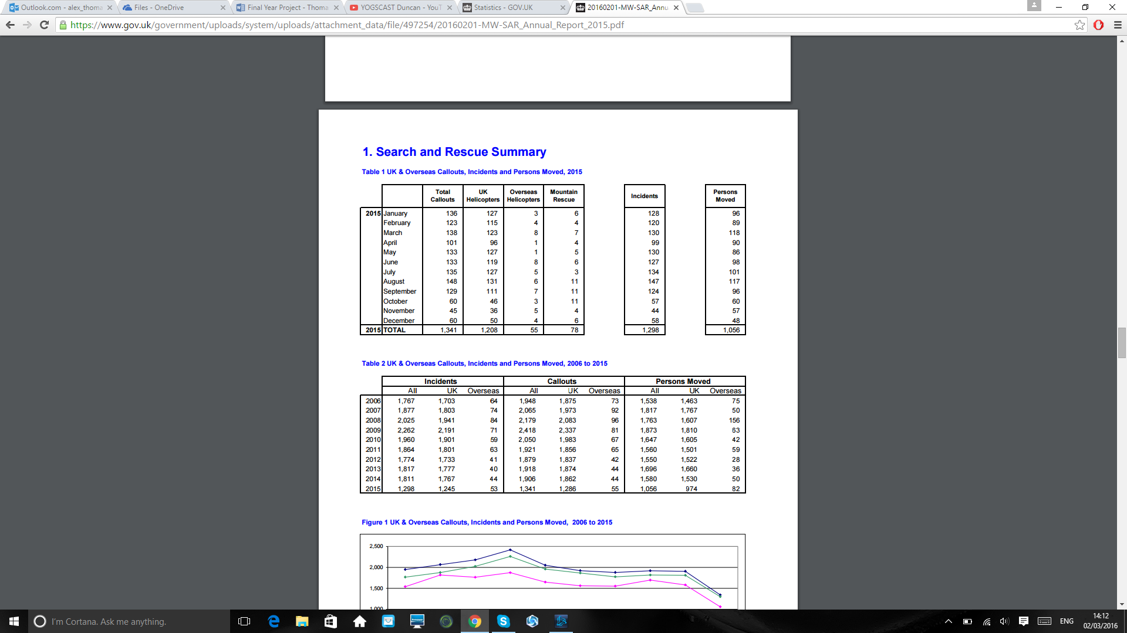

Figure 8: Search and Rescue, UK and Overseas Callout, Incidents and Persons Moved

SAR more often than not relies on unpaid experienced individual volunteers or police that are silos of knowledge within their respected fields. These people understand the tactics and strategies for finding all manner of missing persons, using search theory. To train a volunteer they are given very basic training on search methods and rely on teamwork to cover as much of the search space as possible. With experience these volunteers learn and become experts as they are exposed to different situations. SAR employees need to be physically fit for SAR operation in hazardous environments, such as the sea or the Rocky Mountains. Some situation cannot rely on volunteers for instant when dealing with hazardous material.

Information retrieval, sometime referred to as search and retrieval, it the activity of searching and obtaining information via a search method. This concept is part of our daily lives, for example books, libraries and Search Engines. With books and libraries we can use the glossies or ask for assistance. On the other hand Search Engines have such a complex search space it is impossible to use old reference style systems this is due to information overload. Therefor we have developed search methods and algorithms to aid us. The aims of a search algorithm is to find the desired goal state and retrieve it.

The methods / algorithms SAR teams use are similar to those we use in search and retrieval. The methods SAR team commonly used for rural land base operations are:

* **Bastard Search -** Bastard Search refers to searching in all the obvious places and assuming the person was not really lost at all and found their way home. This method relies on speed and brute-force to find the person search and is carried out by any number of people. Bastard Search is very general and simple, very similar to the brute-force algorithms. Brute-force algorithms operates by checking each candidate solution in turn similar to checking each obvious places such as campsites. This method is very time consuming and can require a large about of effort.
* **Containment –** This method relies on searching around the last point seen of the victim. A person can only move so far, thus you can determine how far to search in a set area. In computing terms, this SAR methods can be seen as a local search. When matching this method to pre-existing search algorithms the hill climber algorithm closely represents this the best. The issue with the method is it relies on the last point seen of the victim / goal state, when there are multiple victim or goal state this method starts to fall apart.
* **Hasty Search –** This approach relies on ten to twelve highly trained searchers. Each searcher is given freedom to approach the problem as they see fit. Each searcher moves independently on their own and is not directed to move along a certain path or in a given direction, this random movement allows them to cover the land quickly. The expected probability of finding the missing person may vary depending on the searchers skills and the search environment. It is estimated, for a well-trained team they have a 30- 40% chance to find the victim. Additionally, if they do not find the person we can assume with 30-40% chance that the victim isn’t there. However, a 60-70% chance of missing the victim is high. The disadvantage with this method is the probability of finding the missing person and the high skills and fitness level required for each individual has to have. Furthermore, without strong communication the system can fall apart.
* **Grid Search** – This method is commonly used as a last resort, as it involves creating a human line or wall and walking across open fields to find the victim. This method is not very effective as it involves lots of manpower and it’s very slow. The approach is unlikely to find any survivors and is more commonly used in criminal investigation where you are looking for evidence such as guns shells. The advantages of this system is it require very little training for new volunteers and is easy to set up.

As you can see SAR methods are ancient and time-tested, but they rely on human volunteers and good communication. Each situation is different, so years of training are required to produce an expert. SAR has very similar links to search and retrieval. Both are types of search, in their purest forms, are looking to find one or numerous goal states within a set environment, whether the environment be physical or virtual. It can be said that the general problem is how to perform searches, rather than how to perform rescue or retrieval. Searching is a broader field and encompasses a range of techniques & methods. But with the advantages in AI can swarm intelligence redefine these ancient and time-tested methods?

(Kentucky Department of Military Affairs, n.d.)

### Application of Swarm intelligence relating to Search and rescuers

Within ‘Swarm-Based Path Creation in Dynamic Environments for Search and Rescue’ (William K. Richard, 2012) William K. Richard and Stephen M. Majercik discusses how to apply Swarm to SAR. They declare that any algorithm, underpinned by swarm intelligence, must locate survivors in a dynamic environment. They also must record their path & locations so these paths can be traversed by human rescuers. The agents they used where flying drones with 4 simple rules:

1. Communicate with each other
2. Locate themselves
3. Identify hazards and survivors,
4. Identify the direction of a survivor

Their design was built around 3 different types of simple agents: Normal Explorers, Bold Explorers (bold explorers are same as normal explorers but take a more aggressive approach) and Path Markers. The explorer’s movement following Craig Reynolds boid model using a pre-set scale vector to control their spacing. Each move an agent makes it recorded and stored, as a result overtime theses random movements build up a path.

Normal explorers and bold explorers is a concept explored by Kinny and Georgeff in 1991. They said that a bold explorer has one single objective and will carry it out without ever stopping to consider changes to the goal or its environment. They found this model works well in a static environment, whilst the normal explore worked better in dynamic environments. (Coppin, n.d.)

When an agent finds a survivor they become a ‘Path Markers’, thus relaying in path to human viewer. When testing they found a swarm of 200 agents have an average approximate of 80% when looking for 5 survivors. The environment was dynamic and set on 600 × 600 meter2 and run for 30 minutes. Comparing this method to SAR’s Hasty Search method with 30-40% of finding the victim their method is more effective by far. They also proposed the robots could broadcasting paths with reference to a fitness value, in addition, they wanted to look at how to deal with static vs. Dynamic environments. The disadvantages they found where memory constraints within the robots and the communication between them.

## Raspberry Pi

The Raspberry Pi is a credit-card sized single-board computer that was created and developed by the Raspberry Pi Foundation. The Raspberry Pi Foundation is a UK registered charity founded (registration number 1129409) in the 2009 with the aim to promote computer science within school (Raspberry Pi Foundation, n.d.). As of 8th June 2015 over six million Raspberry Pis have been sold worldwide (Monk, 2015). The founders Eben Upton, Rob Mullins, Jack Lang and Alan Mycroft, felt whilst teaching at the University of Cambridge A Level students applying to Computer Science courses lacked the required skills. They believed at GCSE and A-level these pupils were learning computer interaction skill such as Microsoft word and Excel rather than coding and hardware. Rather than try rebuilding the ICT curriculum they prototyped small, inexpensive PCs, because they felt that most PCs at home or in school where two vast, costly and complex to experiment on.

The raspberry pie in all accounts is a minimized computer, there have been many iteration’s:

* Raspberry Pi Model A - February 2012
* Raspberry Pi 1 Model A+ - November 2014
* Raspberry Pi 1 Model B - April–June 2012
* Raspberry Pi 1 Model B+ - July 2014
* Raspberry Pi 2 Model B - February 2015

Each iteration has slightly different hardware, with the newer models having improved hardware capacity. Each version operates the same, but the operating system and software define of basic programs and utilities that defines its purpose. Raspbian is the most common operating system for the Raspberry Pi. Raspbian is a modified operating system based on Debian optimized for the Raspberry Pi hardware. This free operating system is also bundled with pre-compiled software bundled, such as python KD and Minecraft.

### Pi2go

The pi2go is a robotics kit form 4tronix that allows you to build a robots that fits onto all models of the Raspberry Pi. For more details please review: <http://4tronix.co.uk/blog/?p=452>. The feature this kit includes are:

#### Hardware:

* One main circuit board
* 5V switching regulator
* 2 DC motors
* 3 x IR Obstacle sensors with indicator LEDs – detect objects within 10cm (left side, right side and front)
* 2 x IR line sensors with indicator LEDs
* Ultrasonic distance sensor - measure the distance to objects in front
* Push button
* 4 pairs of fully controllable RGB LEDS
* 4 light sensors with analogue to digital converter built in
* 4 servo outputs controlled by on-board hardware
* Active Power supply monitor

#### **Software:**

* A python library module is available, it allows other program in interact the robots hardware
* ScratchGPIO version 7 and later fully supports Pi2Go

(4tronix, 2014)

## Summary

This chapter has examined traditional views of intelligence, via looking at John Searle’s and Alan Turing’s views. Their viewpoints, even though different, are both focused on replicating human intelligence. Swarm intelligence challenges these older viewpoint as intelligence is viewed as the emergence of global behaviour from individual simple dumb agents rather than a central controller, such as the human brain.

Swarm techniques, such as the biod model and its use with particle swarm optimization, have many potential applications. One such application is within search and rescue. By studying human based Search and Rescue methods we see they commonly rely on volunteer and specialise to search as much of the search space as possible. This approach as strong ties with swarm intelligence / search and retrieval. But swarm intelligent has many more benefits to current human methods as seen within ‘Swarm-Based Path Creation in Dynamic Environments for Search and Rescue’.

By looking at subsumption architecture and some case studies, we can see how a bottom-up approach fits well into build up simple agents that together can solve complex problems. By breaking down the problem into subsections we can better understand each component. In addition, by utilising swarm intelligent behavior these simple agents can together create an ‘intelligent’ system.

Lastly, we looked at the Raspberry Pi and the Pi2go by 4tronix. These are the baseline hardware components I will use in concoction with the Particle swarm optimization in an attempt to simulate and improve upon human based search and search and rescue.

# Requirements and Analysis

## Introduction

Drawing upon and applying what I have discovered and learn about swarm intelligence from the background research and its application to search and rescue, this section will outline the scope and requirements specification of the project. This chapter’s purpose is to identify requirements for the proposed system, this will include:

* Identifying my aims and objects
* Development Methodology
* UML Use case
* Functional and non- Functional requirements
* Prioritization of tasking, following the MosCoW method
* Detailing the tools I will be using
* Risk Management

## Hypothesis

Can a system that utilizes swarm intelligent behavior, built using subsumption architecture, reliably solve trivialised search and rescue problems? Additionally, would this types of system, consisting of simple agents, act and be consider ‘intelligent’?

## Aim and Objective

To define the scope and requirements of my project I’ve set myself aims and objective to follow. My aims will broadly cover my intention/aspiration and my objective will by how I achieve my aims.

### Aim

My aim is to using the Raspberry Pi 2 Model B in conjunction with pi2go 4tronic robotic kit, is to create anonymous robotic agents. I will build four Raspberry Pi robots with the goal of attempting to make them simulate swarm behaviour. The goal of these robots will be a proof of concept as they attempt to solve trivialised search and rescue problems. The goal state will represent a missing person or people, similar to William K. Richard and Stephen M. Majercik paper and real life situations.

The SAR approach of ‘Hasty Search’, has very similar attributes to swarm intelligence as it relies highly trained searchers working in a team. Each robot will represent an expert searcher as they will move independently and will not be directed to move along a certain path or in a given direction. As coved in my research a well-trained team has a 30- 40% chance to find the victim within a set time frame, improving upon this percent is the main aim of this project.

### Objective

Each objective will follow the S.M.A.R.T system. S.M.A.R.T is an acronym that derives from the first letter of the following words:

* Specific
* Measurable
* Achievable
* Realistic
* Time constrained

My objective are as follows:

* The project will be completed within three prototypes, each with their own time frame. This will be detailed within the design section.
* I will build 4 robots using the Raspberry Pi 2 Model B in conjunction with pi2go before the first prototype.
* Each agent / robot will be goal based, with the goal representing a missing person.
* Once I’ve finished prototyping I will test the system against various test cases. This will include tests against functional requirements and non-functional requirements. The end goal is to improving both the reliability and accuracy, above 30- 40% as detailed with in SAR Hasty Search should be consider a success.

## Development Methodology

Rapid prototyping methodology was first put forward by Toni Stokes Jones and Rita C. Richey with ‘Rapid prototyping methodology in action: A developmental study’ (Toni Stokes Jones, 2000) . Rapid prototyping is a method of quickly building and evaluating a series of prototypes / stages of development. This method follows a non-linear trial-and-error approach, where each previous prototypes is used as a building block for the next iteration. Please see Figure 9 for an illustration of the nature of Rapid Prototyping.

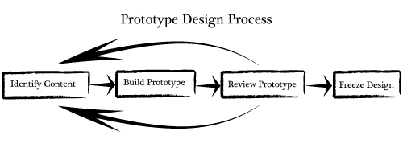

Figure 9: Prototypes Design Process

(Wikiversity, 2010)

The reason I have chosen to follow the prototyping model over others is because of the following reasons:

* Allow me to identify problems early on in development
* Iterative process - trial-and-error approach
* Unlike agile it does rely on teams

## Search and rescue

Each robot is an unmanned ground vehicle. What's more each agent / robot will be totally autonomous, an attribute seen within many other swarm concepts. My system will focus more on searching than rescuing, similar to ‘Swarm-Based Path Creation in Dynamic Environments for Search and Rescue’ and SAR’s search methods. Rather than rescuing the missing person the robots will broadcast the path they took after finding the person, this path can then be followed by human rescuers. Each robot should locate survivors in a dynamic environment by following this subsumption based architecture as detailed bellow:

* Avoided objects
* Communicate with each other

*Search methods utilised*

* + Bastard search method
  + Containment search
  + Hasty search

## UML Use case

To identify the different stakeholder and their interactions with the system I have created a use case diagram, please see Figure 10. The stick figures, commonly called actors, represent the stakeholders and the enclosed box represents the system as a whole. Solid lines represent actions that can be taken and the ovals are the actions. The dotted lines named “extend” are actions, but they are not related directly to the actor.

Use case diagrams, work best when describing and depicting how people interact with the system. As my system is hardware focused identifying the actors is abstract. The actors, ‘Sensors’, ‘LED’, ‘Motor’ are all hardware components and ‘Robot’ being non-physical software. The actions are also abstract as they give an overview of the action performed by the actor.

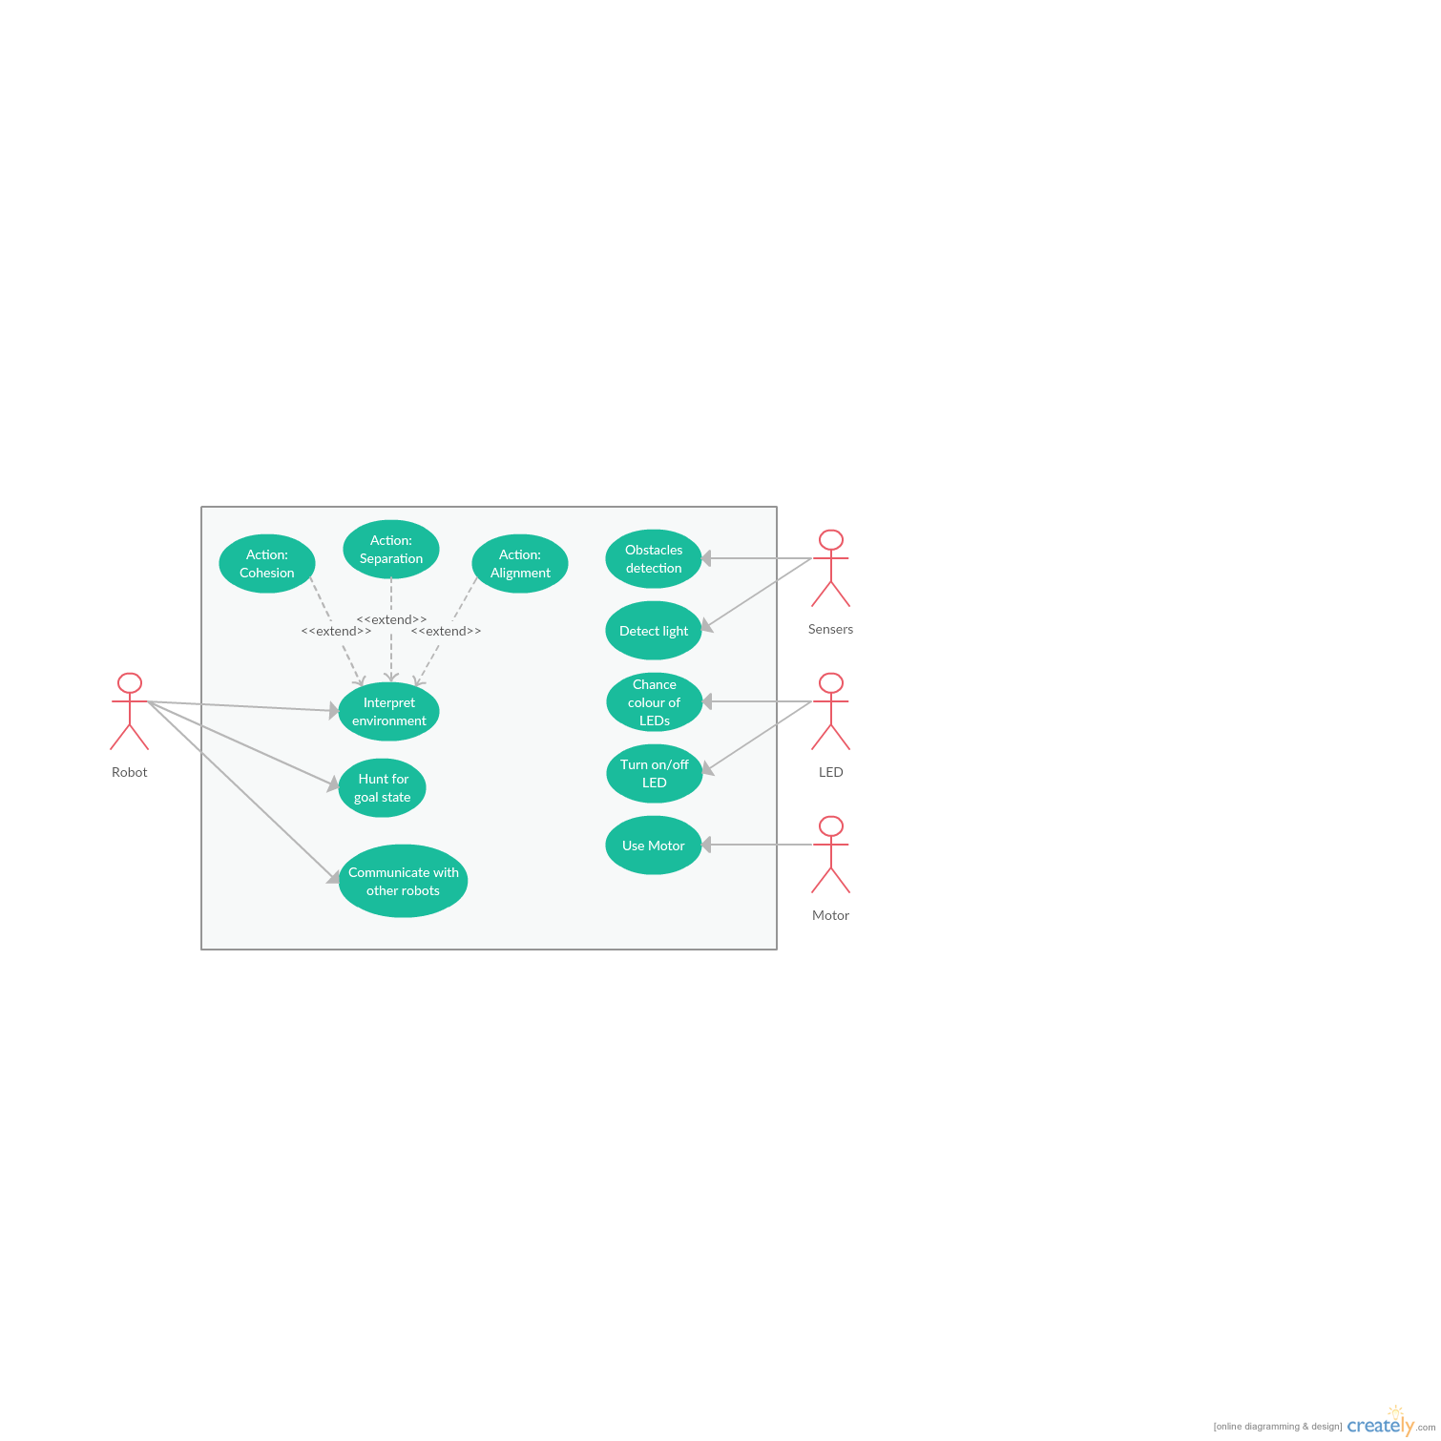

Figure 10: UML Use case diagram

## Functional requirements

To capture high-level requirements I have identified functional requirements. Functional requirement are behaviors’ that describe and detail what the system should do. The Functional requirement I have identified are summarized below:

* **State based** – I’ve created a high level flow diagram, please see Figure 11. This illustrates the states / process flow in a sequentially layout. This diagram shows the basic states of a robot at any given time. By following this design I can easily manage and identify each sub-system.

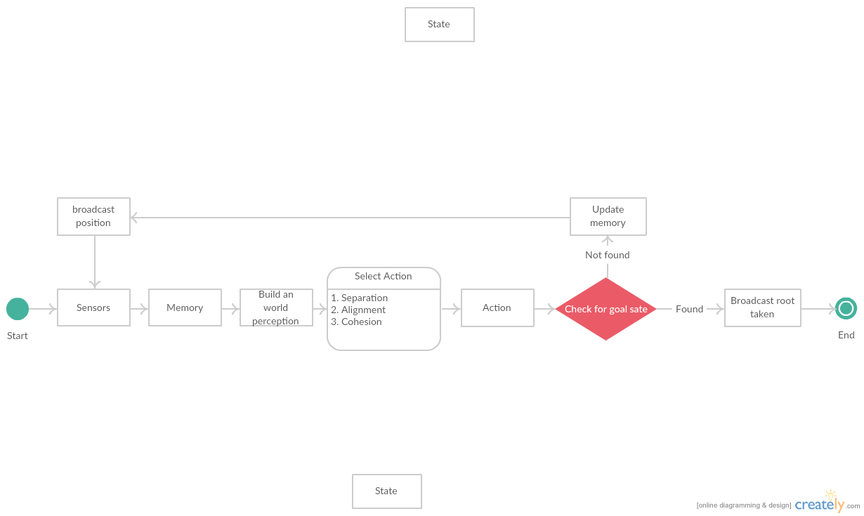

Figure 11: State flow diagram

* **Subsumption based –** When an action is selected it should be based on a Subsumption based architecture and not a sense-plan-act approach. The ‘select action’ state as seen in Figure 11 follows a subsumption architecture. Once the machine builds a perception of its world, it selects an action based on its view of the environment. The action selected will use the particle swarm optimization formula as detailed in Equation 1 and my subsumption based architecture as influenced from SAR.

The strengths of this system are reactivity and parallelism. In spite of this, it's hard to explicitly say and extract knowledge representation and reasoning for each action. I choice this approach over ‘Belief Desire Intention’ and ‘symbolic representation’ because in real life search and rescuer situations the environment is ever-changing.

## Non-functional requirements

Non-functional requirements have no or little impact on the stakeholder / actors, but they allow us to describe the general operation of a system, rather than specific behaviours. Non-functional requirements are commonly applied to the system as a whole, rather than individual features. Please see the list below for the non-functional requirements:

* **Scalability** – Swarms relies on numbers, hence the system should be scalable. However, I will be testing with just 4 robots.
* **Reliability** – Each time the program is run it should have similar results.
* **Environmental** – As I’m dealing with robots, the system should be eco-friendly and green.
* **Well-Documented** – “Programs must be written for people to read, and only incidentally for machines to execute” - (Harold Abelson, 1996). My code should be well documented, thus it will be easy to debug and for others to follow. To make my code easy to follow each class and methods will have its own description explaining what it does.
* **Open Source** – Most of the tools I will be utilising are open source, thus it is only fitting if my source code is open for the public to use and modify.

## MosCoW Prioritization

To aid in managing workflow and priorities I will be following the standard MoSCoW prioritization technique/method. MoSCoW is an acronym that derives from the first letter of the following words:

* Must have – critical to complete the project
* Should have - important, but not necessary
* Could have - desirable but not necessary
* Would like, but won't get – important to some, but ‘cannot’ / ‘will not’ be completed

Table 2 shows how I utilised the MoSCoW approach when ordering priorities of tasks. These tasks include the use cases, functional and non-functional requirements of the system.

|  |  |
| --- | --- |
| Task | Priority |
| * Cohesion * Separation * Alignment * Interpret environment * Hunt for goal state * State based * Subsumption based * Scalability * Obstacle detection | Must have |
| * Communicate with other Robots * Well-Document * Reliability * Open Source | Should have |
| * Detect light * Chance colour of LEDs * Turn on/off LEDs | Could have |
| * Environmental | Would like, but won't get |

Table 2: MosCoW Task Prioritisation

## Tools

To complete this project I will be using the following tools:

### Hardware:

* **Raspberry Pi 2 Model B**
* **Robotic kit** - pi2go kit from 4tronic
* **Mini SD card –** required to use the raspberry pie
* **Wireless adaptor -** required to get raspberry pie to connect to an network

### Software:

* **Raspbian** – Raspbian is the operating system I will use for the raspberry pis
* **Python version 3.4.4** – The framework of the project will be written in the latest version of python.
  + **pi2go’s python package** – This package is prewritten code, provided by 4troinx. It purpose is to allow my code to interact with the robots hardware.
* **Github** – Githut is online open source tool for storing code. This tool allows me to maintain version control and enables the project to be open source

## Risk Management

To manage the risks within my project I have prepared a risk management report. To prepare for any issue that might arise. To create this report I followed these simple steps:

1. Identify risks
2. Assess impact of risks
3. Assess chances of risks
4. Action Plan

Once I’ve identify each possible risk associated with my project, I have calculated their impact and the chance of that risk happening. Both the likelihood/possibility and the impact have been rated between 1 and 5 the score is as follows:

|  |  |
| --- | --- |
| Risk consequence / chance | Score |
| Very Low | 1 |
| Low | 2 |
| Medium | 3 |
| High | 4 |
| Very High | 5 |

Table 3: Risk Management consequence & Score

The overall effect of a risk is calculated by follows equation:

Overall effect = likelihood * consequence

I have followed the RAG (Red, Amber, and Green) grading system to classify risks according to their impact factor. Green indicating low overall effect of the risk, amber for median and red signifying high overall risk to the project. In the case of a risk happening, I’ve created an action plan to follow if the risk did occur.

I have split the risks into 3 different types: project, hardware and software. Please see the tables below for each risk assessment:

### Project Risks

|  |  |  |  |  |
| --- | --- | --- | --- | --- |
| Identify the hazards | Impact rating (0 - 10) | Possibility rating (0 - 10) | Overall effect | Action Plan |
| Illness | 4 | 5 | 20 | Accept |
| Supervisor not available | 5 | 3 | 15 | Deflection – talk to course leader |
| over-running time estimates | 7 | 7 | 49 | Avoid |
| Misunderstanding requirements | 6 | 6 | 36 | Avoid / Accept – each time I complete a section ask supervise to review |
| Having to revisited complete work | 2 | 9 | 18 | Accept |
| Overload of pre-existing work | 1 | 9 | 9 | Accept |
| Aiming too high and not achieving | 4 | 8 | 32 | Avoid / accept – my supervise will tell me if I’ve gotten off track |
| Losing / corruption of the report | 10 | 1 | 10 | Avoid – have mutilate saved in multiple location, with version control |
| Scope is ill defined | 2 | 7 | 14 | Avoid / accept |
| Unrealistic resource levels | 9 | 1 | 9 | Avoid |
| Copyright issues | 10 | 0 | 0 | Avoid / Accept – unlikely to happen, remove the copyright issue |

Table 4: Project Risks

### Hardware Risk

|  |  |  |  |  |
| --- | --- | --- | --- | --- |
| Identify the hazards | Impact rating (0 - 10) | Possibility rating (0 - 10) | Overall effect | Action Plan |
| Circuit board failed | 10 | 1 | 10 | Avoid– will need to replace the robot |
| Broken Sensors | 7 | 2 | 14 | Avoid |
| Broken Ultrasonic distance sensors | 8 | 1 | 8 | Avoid |
| Broken LEDS | 3 | 3 | 9 | Avoid |
| Broken Motor | 5 | 3 | 15 | Avoid |
| Batteries fail | 1 | 9 | 9 | Accept – replace batteries |
| Raspberry Pi brakes | 8 | 1 | 8 | Avoid |
| Broken WIFI adaptor | 4 | 2 | 8 | Avoid |
| Broken keyboard/ mouse | 1 | 1 | 1 | Avoid |
| Broken light sensors | 6 | 1 | 6 | Avoid |

Table 5: Hardware Risk

### Software Risk

|  |  |  |  |  |
| --- | --- | --- | --- | --- |
| Identify the hazards | Impact rating (0 - 10) | Possibility rating (0 - 10) | Overall effect | Action Plan |
| Support pulled/closed for open source library | 10 | 1 | 10 | Accept |
| Buggy open source library | 8 | 4 | 32 | Accept |
| Broken/bugged OS for PI | 3 | 1 | 3 | Avoid – keep a base line to work from |
| Incompatible software | 2 | 7 | 14 | Accept / avoid |
| Not completely Understanding python | 5 | 4 | 20 | Accept |
| Not completely Understanding KD | 3 | 8 | 24 | Accept |
| Scale of my aims / Objects | 7 | 7 | 49 | Avoid / accept – my supervise will tell me if I’ve gotten off track |
| Losing / corruption of my software | 9 | 2 | 18 | Avoid |
| Architecture / design is infeasible | 5 | 5 | 25 | Accept – my design will change throughout my project, this should be reflected in my write up |

Table 6: Software Risks

5

# Design

## Introduction

This chapter will detail the design process that was undertaken following the lifecycle of the project. As detailed in my Requirements and Analysis, the project follows rapid prototyping methodology. As a consequence the design documents have evolved and been refined following this methodology as the final product is a series of non-linear trial-and-error approaches, where the each previous prototype is used as a building block for the next iteration.

The core design for the project has followed the Object-oriented analysis and design (OOAD) approach. OOAD is a widely used approach of analyse the requirements necessary for building and defining a success. My design will cover the following:

* **Hardware**, defining the underlining hardware
* **Class Identification**, analyse each class and their purpose
* **Class relationship**,defining who each class collaborates with
* **System interaction**, Understanding how the system interoperates
* **Pseudocode**, before coding we must understand the core concepts within the system.
* **Rapid prototyping**, an short overview on my aims for each stage of the project
* **Gantt chart**, by following this chart I should be able to control my timeframes

## Hardware

For building the robots I will be following the build guide provided by pi2go. The guide is a step-by-step process that details how to construct the robot. The robot is pre-soldered and assembly is a simple matter of screwing together and plugging connectors. Figure 12 is the hardware schematic, this connected with pi2go library allows access to the hardware. Please see Table 7 for a more detailed overview of the hardware I will be using.

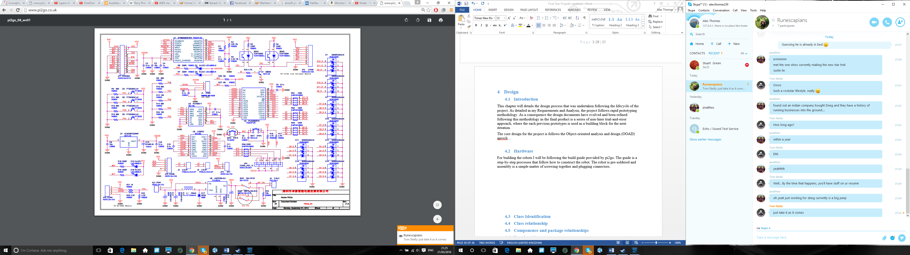

Figure 12: Hardware Schematic

|  |  |
| --- | --- |
| Pi2Go | |
| Main PCBA dimensions (mm) | 110 x 80 |
| PCBA Colour | Red |
| Component technology | Surface Mount |
| Assembly method | Fully soldered |
| Supports Model A, B and B+ (raspberry pi) | Yes |
| Power Supply | 6 x AA |
| 5V Regulator | 3A Switching |
| Battery Monitoring | Yes |
| Light sensors | 4 x analog |
| RGB LEDs | 4 pairs, hardware PWM |
| Ultrasonic sensor | Yes |
| Line sensors x 2 | Yes |
| IR obstacle sensors | 3 with anti-glare technology |
| Wheels | 65mm Yellow |
| Servo connections | 4 (Hardware PWM) |
| I2C Breakout connector | Yes |
| LED indicators for IR sensors | Yes |
| Geared motors ratio | 120:1 |
| Motor connection | Plug & Socket |
| Power connection | Plug & Socket |
| Time to Build (approx. /Varies) | 20 minutes |

Table 7: Overview of Hardware

6

## Class Identification

Following my use case diagram and finite state diagram, as detailed in chapter 3, I textual identified the class required to create such a process using the class-responsibility-collaboration approach. Class-responsibility-collaborate is a brainstorm tool used to identify candidate classes for an object-oriented system. It was first proposed by Ward Cunningham and Kent Beck (Anon., 2001) as a teaching tool, but its popularity grew and now it is used to describe and breakdown complex system in simple turns.

The method relies on creating simple cards for each class, on each card it consist of three sections:

1. **Class name** : Name of the class, should reflect the classes purpose
2. **Responsibilities** : The behaviours, functions methods of the class
3. **Collaborations :** What other classes does it interact with

Please seem bellow for the class-responsibility-collaborate cards:

|  |  |
| --- | --- |
| Class name | MiddleWare |
| Responsibilities | Middleware – externalizes all hardware into simple commands |
| Collaborations | * Adafruit_PWM_Servo_Driver * Action |

Table 8: Class-responsibility- collaborate cards – MiddleWare

|  |  |
| --- | --- |
| Class name | Adafruit_PWM_Servo_Driver |
| Responsibilities | Connects the hardware pins to software function |
| Collaborations | * MiddleWare |

Table 9: Class-responsibility- collaborate cards - Adafruit_PWM_Servo_Driver

|  |  |
| --- | --- |
| Class name | Action |
| Responsibilities | The main controller of the robot, following the state diagram as detailed in my ‘Functional requirements’. Furthermore, it will follow my subsumptuion based architexture   * Avoided objects * Communicate with each other   *Search methods utilised*   * + Bastard search method   + Containment search   + Hasty search |
| Collaborations | * MiddleWare * Communication |

Table 10: Class-responsibility-collaborate cards – Action

|  |  |
| --- | --- |
| Class name | Communication |
| Responsibilities | Controls communication between robots |
| Collaborations | * Action |

Table 11: Class-responsibility-collaborate cards - Communication

Both MiddleWare and Adafruit_PWM_Servo_Driver are free open source files, created by Gareth Davies and Zachart Igielment, June 2014. Their code is in the public domain and is free to use and modify. The focal point of my project is swarm technology and it application in search and rescue and not hardware, as result I will not be covering these classes in depth.

## Class relationship

Previously we identified the class require to create the system, their responsibilities and the other classes they should collaborate with. The next step is to show how these classes interact with each other in a more rigidly static way, we will achieve this by using a class diagram. Using the standard UML class notation, as seen in Figure 13, I have illustrated the overarching build of the system. As you can see the diagram is very simplistic as it does not include methods or attributes. The reason for such a simple diagram was to demonstrate the simple agent’s design.

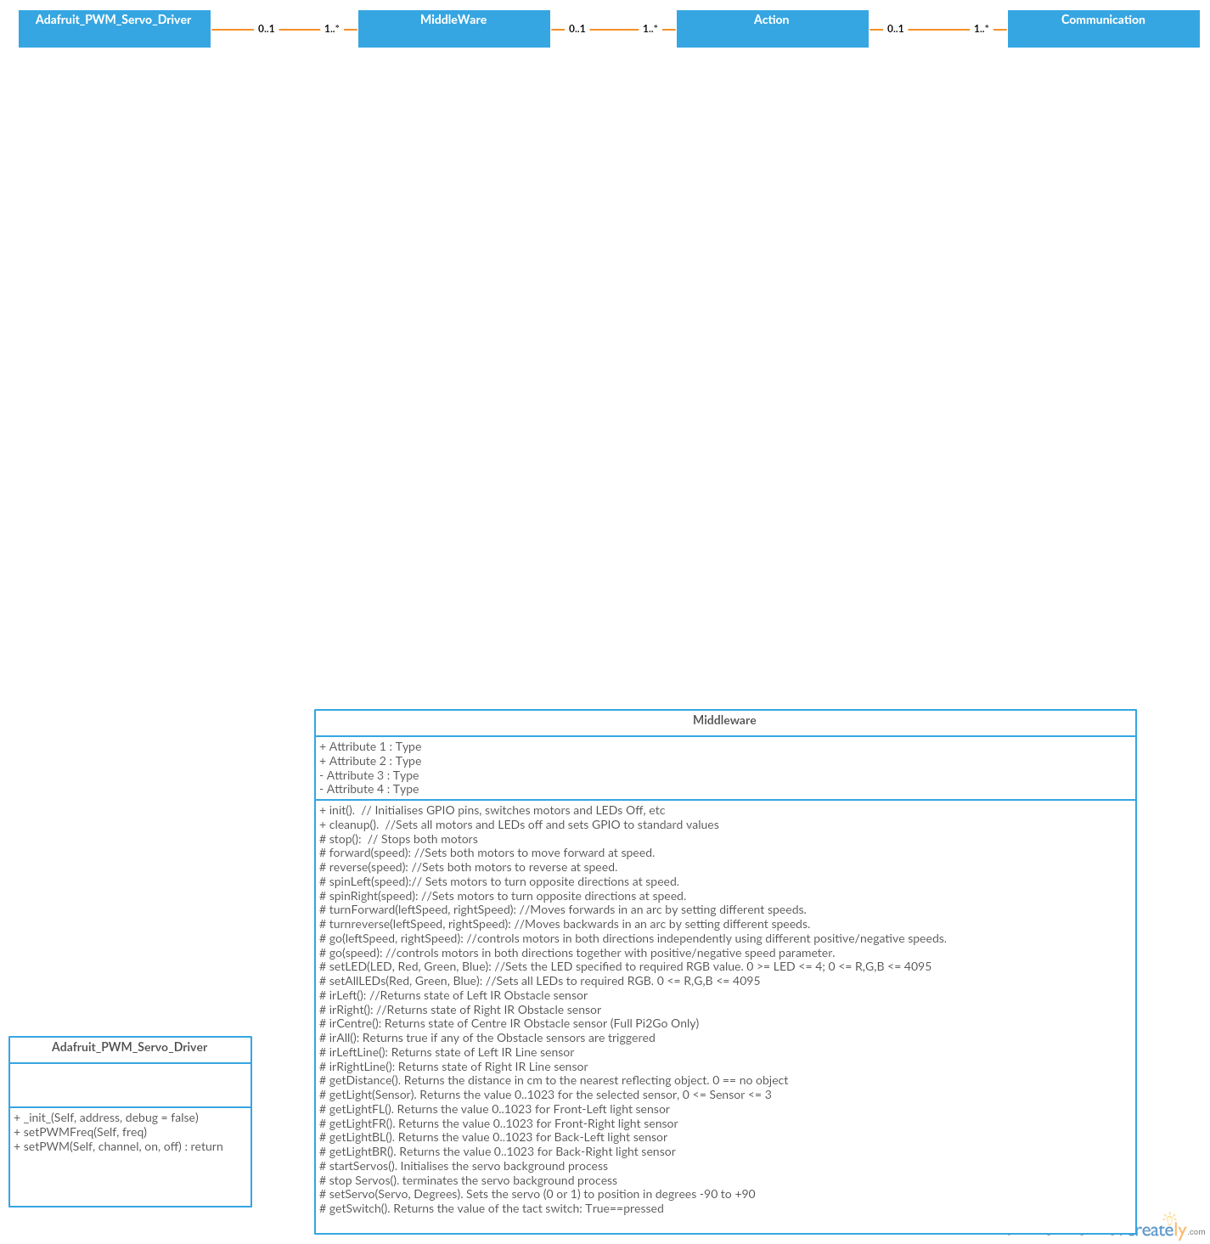

Figure 13: Simple class diagram

Please see Figure 14, Figure 15 and Figure 16 for more details on each class. These class diagrams detail each class by showing their methods and attributes, this extra complexity shows the system to its fullest and how it will translate from the designed process into a functioning system. Within each diagram you may notice the lack of ‘private’, ‘public’ and ‘protected’ declarations, this is due to python not fully supporting these concepts. Furthermore, ‘Middleware’ has many functions and attributes, however I have only included function relevant to the pi2go. I did not include the adafuit class diagram this is because my code interacts with ‘middleware’, thus from my codes point of view this class does not ‘exist’.

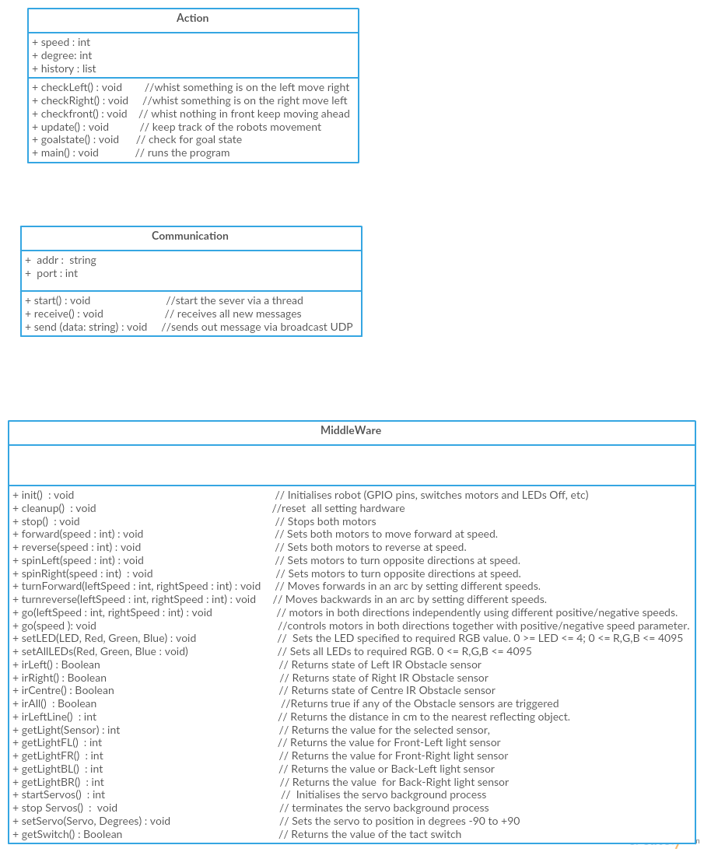

Figure 14: Middleware class diagram



Figure 15: Action class diagram



Figure 16: Communication class diagram

## System interaction

To understand the scope and how the system will interoperate I have created an UML sequence diagram, please Figure 17. This diagram describes the interaction made among the different classes within the system. Figure 11 as detailed in prior chapters show the different states of the system at any given time. Similar to above I have not included the ‘adafuit’ class, this due to utilising ‘MiddleWare’ all it hinds and automatically passes down commands to the hardware.

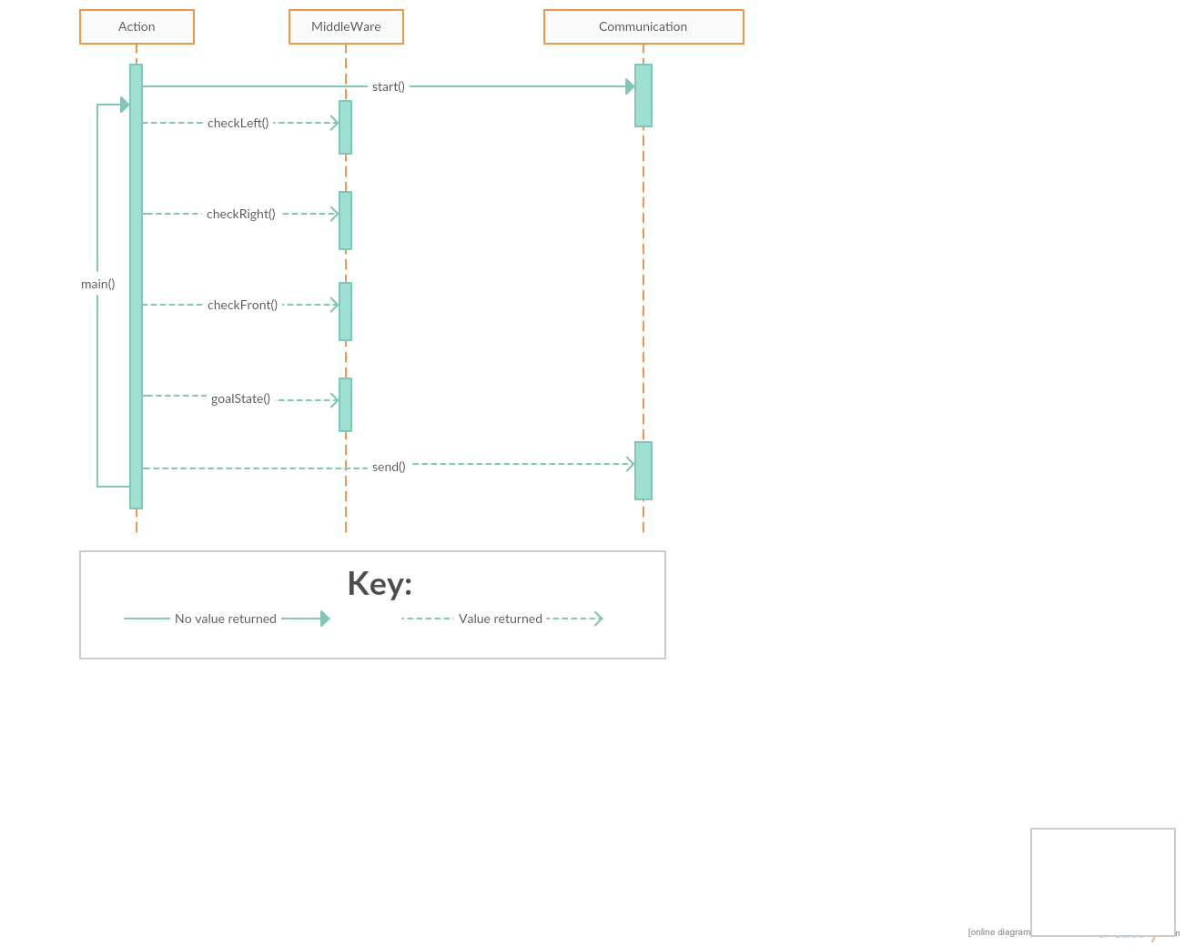

Figure 17: UML sequence diagram

## Pseudo code

Before we write each method and their algorithms, we must understand their tasks and roles. For each major method I have write out its pseudocode. Please note I’ve not included any method within ‘MiddleWare’ and ‘Adafruit_PWM_Servo_Driver’ due to the code is publicly available.

### Main

Middleware.init() //starts the hardware

Communication.init() //starts the communication class

Try:

While true:

check-left ()

check-right ()

check front ()

search method()

Finally:

Middleware.cleanup //stops the hardware

This in a simple form subsumption architecture I designed, it follow the following priorities:

* Highest priority: evade
* Then: find goal - this is called inside check front()
* Then: update memory / broadcast location – again this is called within goal state()

### Left and Right

#### Left

Method check-left ()

If left sensor == true

While left sensor == true

Spin Right

Degree + 90

Stop robot

#### Right

Method check Right ()

If Right sensor == true

While right sensor == true

Spin Left

Degree - 90

Stop robot

### Front

Method check front ()

While (left sensor & Right sensor) == false

If front sensor >= set distance

Move forward

Look for goal state

Update history

Else

If random number > 0.5

Spin Right

Degree + 90

Else

Spin left

Degree - 90

Stop robot

### Update history

Int degree = 0

Array history [[ ]] // an list of lists

Method update ()

New location = History [last location in array]

If degree == (0 or 360 or -360)

degree = 0

New location [1] += 1

Else if degree == (90 or - 270)

New location [0] += 1

Else if degree == (180 or - 180)

New location [1] += 1

Else if degree == (270 or -90)

New location [0] -= 1

History.add (new location)

This method work out where the robot has moved, its base location is set to [0, 0] this corresponds to [x, y]. ‘History’ after the robot moves, would look something like this [[0, 0], [0, 1], [0, 2]…]. ‘degree’ as also seen in ‘left’ ,’right’, ‘front’ is the way the robot is facing. The system work in 90 degree angles, see below for all it states:

* 0°
* 90°
* 180°
* 270°
* 360°
* -90°
* -180°
* -270°
* -360°

### Goal state

Method goal state ()

If (left lower sensor or right lower sensor) == true

Stop robot

Turn on LEDS

Broadcast history

Break out of main loop

The goal state is a black dot on a white floor, this represents a missing person. Once the lower sensors identifies the change from black to white, they run this function. In a real life search and rescue situation this goal state could be heat sensors or machine vision to identity a human.

### Sender

Address = x.x.x.x

Port = xxxx

Method send (data)

Create socket

Bind to socket

Send date to (address, port)

### Receive

Address = x.x.x.x

Port = xxxx

Method receive ()

Create socket

Bind to socket

While true

Update memory once new data arrives

## Rapid prototyping

As outlined within chapter five, this project will operate and follow rapid prototyping. Each stage will begin with identify basic requirements and reviewing the progress from the previous prototype. From identifying the basic requirements we can developed each prototype to build towards a final product. The tables below detail each prototyping and the prerequisite stage.

### Prerequisite

|  |  |
| --- | --- |
| prerequisite | |
| Timescale | Start: September 2015  Finish: October 2015 |
| Aims | 1. Construct four pi2go robots 2. Configure each raspberry pi 3. Download the python library module from pi2go and the required add-ons |
| Objectives | 1. By following the build guide provided by 4tronix, found at: <http://4tronix.co.uk/blog/?p=452> , I will construct each robot 2. Format the SD card under FAT (File Allocation Table). Install ‘raspbian’, using Noobs, an operating system installer. Both Noobs and raspbian download can be found at: <https://www.raspberrypi.org/downloads/> 3. Download the pi2go accompany python library/package. The download can be found: <https://github.com/the-raspberry-pi-guy/robot> |

Table 12: Rapid Prototyping – prerequisite

### Stage One

|  |  |
| --- | --- |
| Stage One | |
| Timescale | Start: October 2015  Finish: December 2015 |
| Aims | 1. Create the basic class classes and their methods |
| Objectives | 1. Build classes and method templates, but do not implement the code 2. Fill out all method that involve direct contact to ‘MiddleWare’ (hardware) |

Table 13: Rapid Prototyping - Stage One

### Stage Two

|  |  |
| --- | --- |
| Stage Two | |
| Timescale | Start: December 2015  Finish: January 2016 |
| Aims | 1. Create the networking component / class 2. Create the memory method / component |
| Objectives | 1. Create a server and client using UDP broadcast. This will allow all robots to send and receive messages using the same port and IP. The reason why I choice UDP broadcast as it in keeping with the concept of dumb agents 2. Implement a simple method that tracks movement, that takes reference the robots movements and environment 3. The robot could have informed decisions based on the robots around it. |

Table 14: Rapid Prototyping - Stage Two

### Stage Three

|  |  |
| --- | --- |
| Stage three | |
| Timescale | Start: January 2016  Finish: March 2016 |
| Aims | 1. Implement the partial swarm algorithm, as detailed in Equation 1. 2. Add the subsumpution based SAR search methods, as see in ‘Search and rescue infulance’ – 3.5 |
| Objectives | 1. I will implement the partial swarm algorithm implement this into the robots as seen in Equation 1. 2. Finally I will add the different layers of SAR search |

Table 15: Rapid Prototyping - Stage Three

## Project tine

To manage my time effectively I have created a Gantt chart, please see Figure 18. The purpose of a Gantt chart is to show activities (tasks or events) displayed against time. On the left is each chapter of my report, and along the top is the academic weeks. Each green square represents how long the task will take to complete.

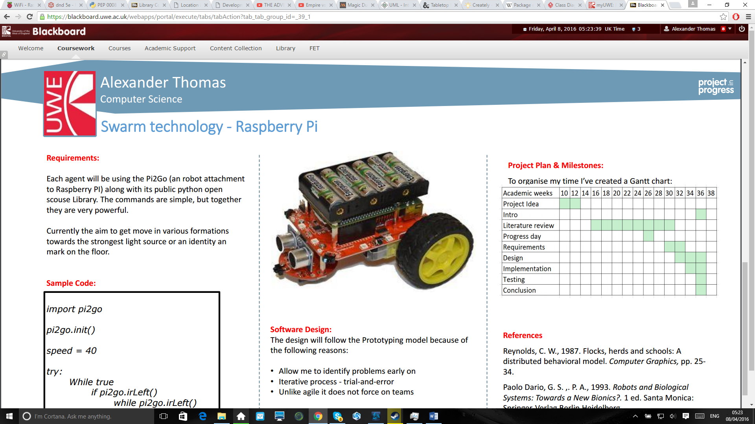

Figure 18: Gantt chart

# Implementation

## Introduction

This chapter will cover the process of implementation of the framework detailed within the design chapter, accordingly and in keeping with my aims and objectives. Following the rapid prototyping methodology I will aim to complete the project within three prototype / iteration, as detailed within my Design. Each prototype is broken down into several stages, this allows me to ‘divide and conquer’ each section independently approach.

### Prerequisite

To build each robot I followed the build guide provided by 4tonix, as detailed within the design chapter, the assembly was simply a matter of screwing together / plugging connectors. The raspberry pi was equally easy to configure. The next step was to format the SD card under FAT (File Allocation Table). Following this I used ‘noobs’, an operating system installer, I was able to deploy raspbian the officially supported operating system for raspberry pi. Next I connected and configured the wireless connection using the USB Wireless adaptor.

Now with access to the internet I needed to update python. In addition, I needed to install inter-integrated circuit’. Inter-integrated circuit, commonly shortened to I2C, is a communication protocol specifically designed to talk to hardware. To complete this I follows these steps:

1. Opened ‘Lxtermial’ – the standard terminal emulator  for the pi
2. To insure the python was up to date I entered the following command: “sudo apt-get install python-smbus”
3. To install IC2 I inputted the following command: “sudo apt-get install i2c-toolss”
4. Next the raspberry pi required a reboot
5. To test, if IC2 was success installed I again open ‘Lxtermial’ and run “sudo i2cdetect -y 1”. Figure 19 show the end result if the steps was correctly followed.

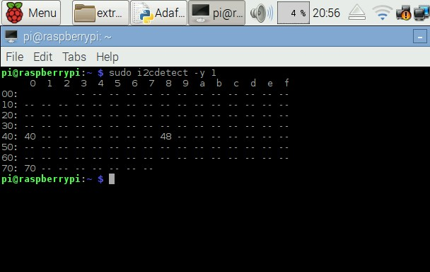

Figure 19: 'sudo i2cdetect -y 1' Command

To download the python library module, I followed these steps:

1. Opened ‘Lxtermial’
2. By inputting the command “git clone <https://github.com/the-raspberry-pi-guy/robot>” I download the pi2go python package
3. Using the GUI I moved the packet into a suitable location
4. To make sure the packer installed correctly view the sample program using the GUI or via command line using “*sudo nano*avoid. py”
5. Next to test the program via the GUI or via command line using “sudo python avoid. py”.

### Issues encountered

One issue I encountered was memory constraints on the raspberry pi. I did not account for the size of the updated python library and pi2go python package; as a result once I run the sample program it over ran the block size of the operating system, thus making the operating system unusable. To resolve this issue I resorted to my risk management, Table 6, under ‘broken/bugged OS’. As stated within my risk management “Avoid – keep a baseline to work from”, to solve this issue I reformatted the SD card, and before installing the python library module I removed any unneeded programs and files from the SD card.

## First prototype

At this stage the raspberry pi operating system has been configured, furthermore the pi2go python package is installed and working. The core aims of this first stage of this prototyping to build the framework for the further development. As a result I created all the baseline classes and method described in my design section. However, I did not implement any methods, as my project would build up towards them.

The first method I built within the action class I was checkLeft and checkRight. This method, as detailed above, scans the local area to see if anything is picked up on the right or left sensors. Please see below for the code:

### ****Check left method****

def checkLeft():

if MiddleWare.irLeft():

while MiddleWare.irLeft(): # While the left sensor detects some move right

MiddleWare.spinRight(speed)

degree - 90

MiddleWare.stop()

### Check right method

def checkright():

if MiddleWare.irRight():# While the right sensor detects some move left

while MiddleWare.irRight():

MiddleWare.spinLeft(speed)

degree + 90

MiddleWare.stop()

### Check front method

The next method I added was checkFront. The purpose of this method is to avoid objects directly in front of the robots. Please see below for my code:

def checkFront():

while not (MiddleWare.irLeft() or MiddleWare.irRight()):

if MiddleWare.getDistance() >= 0.3:

# If the distance is less than 0.3, spin right for 1 second

MiddleWare.forward(speed)

update()

else:

if random.random() > 0.5:

MiddleWare.spinRight(speed)

degree - 90

else:

MiddleWare.spinLeft(speed)

degree + 90

MiddleWare.stop

### Goal state method

The final method I added was goalState. This method uses both lower sensors to detect if the black mark is here. Once the goal state is located, via search, the system broadcast it location. Please see code below:

def goalState():

if MiddleWare.irLeftLine() or MiddleWare.irRightLine():

time.sleep(1)

history.append('goal reached')

# add later - send message to others robots

else:

time.sleep(1)

# add later - send message to others robots

### Issues encountered

One hindrance I encounter was only being able to run the hardware while I was remotely connected. The hardware fails to setup correctly if the power or HMI cables are connected. This was frustrating, but not mission critical, to get around this issue I needed to SSH (Secure Socket Shell, a network protocol that can access a remote computer) from my personal computer using ‘Putty’, a free terminal emulator, onto the raspberry pi. SSH on raspberry pi is enabled by default. Please see Figure 20 for proof:

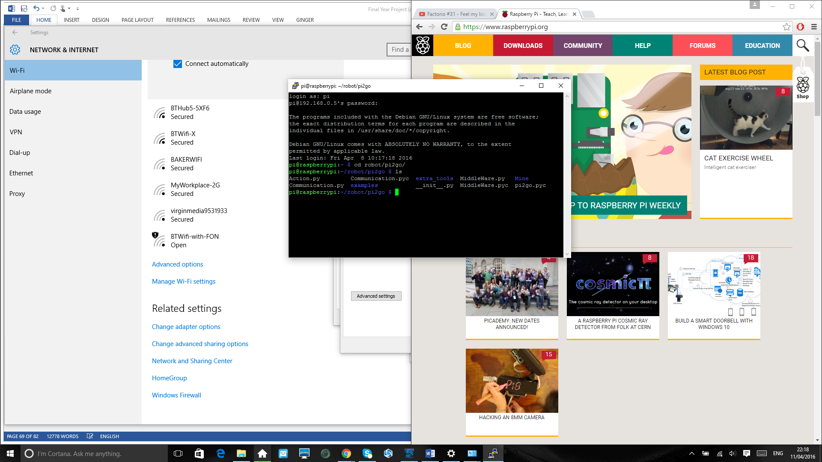

Figure 20: SSH connection

## Second prototype

Before moving onto the next stage I first reviewed the pervious stage. As a result I was able to fix some bugs within the software, for instance I forgot to import the random number generator module. This reviewing concept of trial-and-error was invaluable and allowed me to fix more complex issues.

### Communication class

The first objective of this stage was to create the networking component. I built a simple server using ‘User Datagram Protocol’ (UPD) and IPV4. I chose UPD over ‘Transmission Control Protocol’ (TCP) for two reasons. Whilst data is not guaranteed to arrive using UDP, nor are they guaranteed to arrive in the same sequence in which they are sent, it is connectionless thus saving memory. This is important as the raspberry pi can only do so much. Moreover, unlike TCP UDP supports broadcasting. This allows me to send the same message to all the robots just using one IP.

The port number is set to: **5000.**

This number must be in the range 1,024 to 65,535. As this range is outside of IANA

IP is set too: **192.168.0.255**.

This will allow me to send messages to all address from 192.168.1 – 254 using UPD broadcasting. This system can thus support up to 254 robots.

Please see below for my code:

import socket

import structs

import thread

addr = '192.168.0.255'

port = 5000

def start():

threading.Thread(target = receive).start()

def receive():

sock = socket.socket(socket.AF_INET, socket.SOCK_DGRAM, socket.IPPROTO_UDP)

sock.setsockopt(socket.SOL_SOCKET, socket.SO_REUSEADDR, 1)

sock.bind(('', port))

while True:

#update history

print sock.recv(1024)

def send(data):

sock = socket.socket(socket.AF_INET, socket.SOCK_DGRAM, socket.IPPROTO_UDP)

sock.setsockopt(socket.IPPROTO_IP,socket.IP_MULTICAST_TTL, 2)

sock.sendto(data,(addr, port))

This method does have its drawbacks, for example it is currently is unable to handle missing, duplicate, and out-of-sequence datagrams. But this could he added at a later date. Furthermore, I feel UDp when dealing with life or death situations such as SAR is not really appropriate. Furthermore, it relies on a nearby rooter to send the messages, again this is not really suitable for SAR. Nevertheless it does work and uses little memory.

### Update method

The final stage is to implement a method of tracking the robots movements. Each robots base location is set to [0, 0] this corresponds to [x, y]. After each time the robot moves forward it updates it location. For example the data would look something like this [[0, 0], [0, 1], [0, 2]…]. Each time the sensors detect something on the left or right the robots angle changes. When the robots rotates left it’s calculated at -90° and right to +90°.

Due to the current system only working in 90° angles it does handicap it somewhat. This could be improved using smaller angles, but I fear this would make the system become very complex very quickly. Moreover, as each system start at [0, 0] when they pass their coordinates they are personal to the robots, and not its environment.

To resolve this issue I looked at other technology rather than using my method. I considered GPS, but for the environment scale I was using it was not suitable. GPS has about 5 meter precision radius and require unobstructed line of sight to four or more GPS satellites. This would be suitable for large scale SAR aerial system, but small land based system it was a large setback that I was not able to overcome.

def update():

global history

global degree

newlocation = history[-1][:] # get the last value in the list

if degree == 0:

newlocation[1] += 1

elif degree == 90 or -90:

newlocation[0] += 1

elif degree == 180 or -180:

newlocation[1] -= 1

elif degree == 270 or -270:

newlocation[0] -= 1

elif degree == 360 or -360:

degree = 0

newlocation[1] += 1

history.append(newlocation)

# Communication.send(history)

## Third prototype

I spend a lot of time trying to overcome the communication issue detailed within my second prototype. In the end I set each robot location to [0, 0], [0, 1], [0, 2] and [0, 3]. This system represented the SAR grid search methods detailed in my research, even though it was not made on purpose.

Due to time and issue outlines above I was unable to complete the third stage. If I was to implement particle swarm it would have follow something like this:

    Initialize each robot

Do  
    For each robot  
        Calculate fitness value  
        If the fitness value is better than the best fitness value (pBest) in history  
            set current value as the new pBest  
    End  
  
    Choose the robot with the best fitness value, that fitness equals gBest  
    For each robot  
        Calculate robots velocity / update robots position according to Equation 1.  
    End   
While maximum iterations or until goal state has been reached

The fitness value would be difficult to define or calculate as it would change depending on each type of SAR mission, but for my prototype I would set it as zero or one. One would representing found person and zero would equalling nothing found. The learning rates, sometimes called the constant weights, would also be hard to define or calculate as again they would depend on the real life application.

Finally with more time I would have tried to implement Figure 21. I reason that this system, if fully operational would work in real life dynamic environments as it would use preexisting SAR methods and it movement would be controlled by the particle swarm. I feel like I have tried to achieve too much with a short time frame and limited hardware knowledge. Whist the system is not fully completed, ‘avoid object’, and part of ‘communicate currently work.

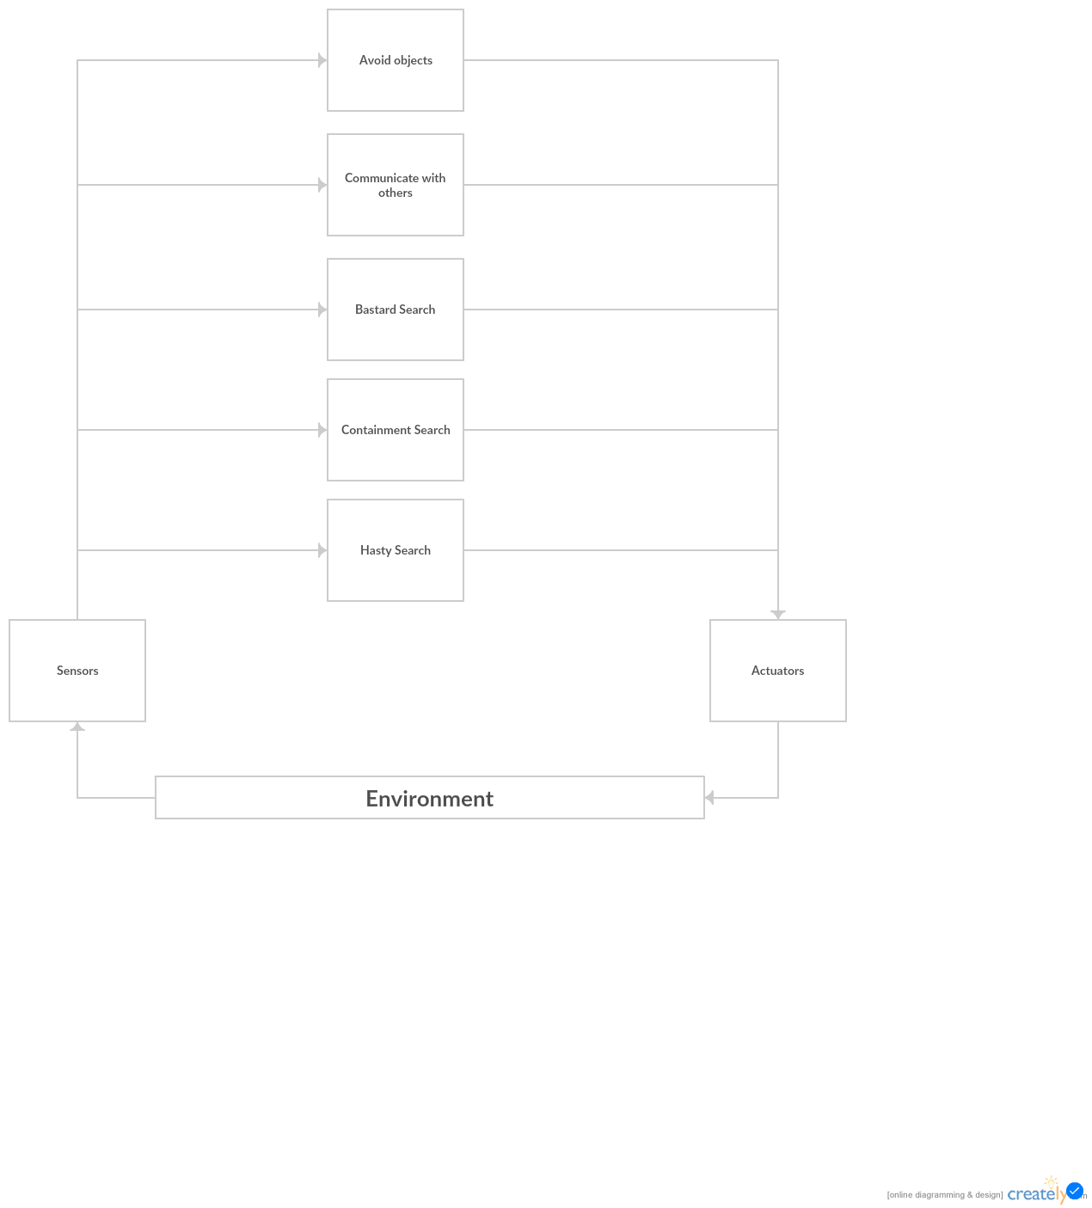

Figure 21: SAR based subsumption architecture

# Testing

In this chapter, we will describe the process for testing the projects software. Software testing is necessary because as humans, we can always mistakes, as a result, we need to check our work. By identifying errors it allows us to improve the overall reliable and performance of the product. It has also allowed us to compare the product to its requirements and design. Due to the fact I am using rapid prototyping methodology this becomes more relevant for each prototype.

Ideally the test should be checked by another person under set guidelines, as this way they are more likely to spot the errors. However, as my system is not dependent on humans’ actors this method is not functioning. To compensate for this I have built a wide array of acceptance test this will allow me to test the overall performance of the system, rather than just finding software bugs.

## Functional requirements testing

The test cases bellow will focus on functional requirements testing.

|  |  |
| --- | --- |
| Test Case Identifier | Use case diagram |
| Description | Does the system build resemble the use case diagram, as seen in Figure 10? |
| Input Data / State | N.A |
| Preconditions | N.A |
| Expected outcome | N.A |
| Outcome | Pass – I feel most, if not all, actions have been achieved. |

Table 16: Functional requirements testing - Use case diagram

|  |  |
| --- | --- |
| Test Case Identifier | Avoid objects left |
| Description | Do the robots avoid object to the left? |
| Input Data / State | N.A |
| Preconditions | Object was placed in front of the left sensor |
| Expected outcome | The robot move to the right |
| Outcome | Pass |

Table 17: Functional requirements testing - Avoid objects left

|  |  |
| --- | --- |
| Test Case Identifier | Avoid objects right |
| Description | Do the robots avoid object to the right? |
| Input Data / State | N.A |
| Preconditions | Object was placed in front of the right sensor |
| Expected outcome | The robot move to the left |
| Outcome | Pass |

Table 18: Functional requirements testing - Avoid objects right

|  |  |
| --- | --- |
| Test Case Identifier | Avoid objects front |
| Description | Do the robots avoid object in front? |
| Input Data / State | N.A |
| Preconditions | Object was placed in front of robot |
| Expected outcome | The robot move to the left or right |
| Outcome | Pass |

Table 19: Functional requirements testing - Avoid objects front

|  |  |
| --- | --- |
| Test Case Identifier | Movement |
| Description | Do the robots move forward? |
| Input Data / State | N.A |
| Preconditions | N.A |
| Expected outcome | Whist there are no object blocking its path the robots was always move forward. |
| Outcome | Pass |

Table 20: Functional requirements testing – Movement

|  |  |
| --- | --- |
| Test Case Identifier | Goal state |
| Description | Can the robots identify the goals state? |
| Input Data / State | N.A |
| Preconditions | The floor must be white, thus making the back dot is a contrasting colour |
| Expected outcome | They should perceive the black dot on the floor. |
| Outcome | Pass |

Table 21: Functional requirements testing - Goal state

|  |  |
| --- | --- |
| Test Case Identifier | Communication |
| Description | Can the robots communicate and use that data to update their view of the environment? |
| Input Data / State | ‘Data’ (a robots location) is send from one robots to all others. |
| Preconditions | N.A |
| Expected outcome | Each robot will receive the data and update their view of the environment. |
| Outcome | Partly successful – they can send message to each other, but the message have no real meaning |

Table 22: Functional requirements testing - Communication

|  |  |
| --- | --- |
| Test Case Identifier | Flow diagram |
| Description | Do the robots follow the flow diagram as seen in Figure 11? |
| Input Data / State | N.A |
| Preconditions | N.A |
| Expected outcome | N.A |
| Outcome | Partly successful – they follow the general flow, but the exact step. |

Table 23: Functional requirements testing - Flow diagram

|  |  |
| --- | --- |
| Test Case Identifier | SAR subsumption architecture |
| Description | Does each robot follow the outlined SAR subsumption architecture? |
| Input Data / State | N.A |
| Preconditions | N.A |
| Expected outcome | N.A |
| Outcome | Failed – this is due to the system not have having this functionality build |

Table 24: Functional requirements testing - SAR subsumption architecture

## Non-Functional requirements testing

The test cases bellow will focus on non-functional requirements testing:

|  |  |
| --- | --- |
| Test Case Identifier | Scalability |
| Description | Swarm intelligent relies on numbers, hence the system should be scalable. |
| Input Data / State | 4 robots |
| Preconditions | N.A |
| Expected outcome | Adding extra robots will only aid in the search |
| Outcome | N.A – due to costing I only have 4 robots. Thus this is very hard to test, but I cannot see how it would negatively affect their search. |

Table 25: Non-functional requirements testing – Scalability

|  |  |
| --- | --- |
| Test Case Identifier | Reliability |
| Description | Each time the program is run it should have similar results. |
| Input Data / State | Different set environments within , but with the same about of robots |
| Preconditions | N.A |
| Expected outcome | The system should perform above 40% success rate within a 20 mins demo in an 10 by 10 foot dynamic environment |
| Outcome | N.A – testing this system was very difficult to perform. As a result were different each time, and I unable to get an solid answer |

Table 26: Non-functional requirements testing – Reliability

|  |  |
| --- | --- |
| Test Case Identifier | Environmental |
| Description | As I’m dealing with robots in the system should be eco-friendly and green. |
| Input Data / State | N.A |
| Preconditions | N.A |
| Expected outcome | N.A |
| Outcome | Failed - I found that the robots are very power hungry, and using non rechargeable AA batteries as power source was not sustainable. To resolve this issue I could use other methods of powering the robots, but this would be more expensive as a result. |

Table 27: Non-functional requirements testing – Environmental

|  |  |
| --- | --- |
| Test Case Identifier | Well-Documented |
| Description | Is my code well documented, Is it easy to debug and for others to follow? My will be revived by a other human looking at comments and |
| Input Data / State | N.A |
| Preconditions | N.A |
| Expected outcome | The onlooker would find the good understand and easy to follow |
| Outcome | Pass – Overall they found my comments helpful, as tit outlined each method, main attributes and the overall purpose of the class.  However, they did note that the class start to be more comments that code, thus the overall flow was hard to follow. |

Table 28: Non-functional requirements testing - Well-Documented

|  |  |
| --- | --- |
| Test Case Identifier | Open source |
| Description | Can the system be consider open source? Most of the tools I will be utilising are open source, thus it is only fitting if my source code is open for the public to use and modify |
| Input Data / State | N.A |
| Preconditions | N.A |
| Expected outcome | N.A |
| Outcome | Pass - All the tools used thought-out where free open source tools, furthermore my code is available on request |

Table 29: Non-functional requirements testing - Open source

# Conclusion

## Introduction

This chapter will evaluate and reflect upon the project as a whole. I will begin by reflecting upon and critically evaluating each stage of the project. Subsequently I will look at future work that can be done within the field. Finally I will give a closing statement to the project,

## Reflection

### Reflection on Research

It is clear to say that swarm intelligence challenges the traditional views of intelligence. From my research and my personal viewpoint the application of the human brain, true intelligence, can be applied to many situation. It would appear that swarm intelligence is limited to set problems. Furthermore, swarms only appear intelligent if it solve the problem. If it fails to find the goal the system as a whole could be consider useless.

The biod model is a simple concept that outline our current views on biological swarms, by following this theory it makes the system look ‘alive’. Subsumption architecture is another simple concept with powerful outcomes, this layer construction can creates some truly intelligent system. However, I feel its implementation is more an art that science.

From my research, search and rescue commonly rely on volunteers and specialists to search as much of the search space as possible. Most method of search and rescue are brute force focused, and as a result they are ineffective. The only search method that could be conceded an intelligent search method would be hasty search. Search and rescue has strong ties with search and retrieval; as a result applying swarm intelligent could have interring results, as seen within ‘Swarm-Based Path Creation in Dynamic Environments for Search and Rescue’.

**Strengths**

* Comparing current human based method of search and rescue against AI search and retrieve method has shown to have very strong ties
* The biod model and subsumption architecture have heavily influence on robotics and swarm technology.
* We have discover that current search and rescue method rely on brute force to solve the problem, as a result they are time consuming and heavily reliant on manpower.

**Weakness**

* Rather than investigating swarm technology I could have focused more on its application to search and rescue.
* There are many other types of search methods, I feel I missed an opportunity to review and see how they perform in SAR problems.

**Improvement**

* Valentino Braitenbreg, in the 1980, suggested building different versions of robots to better understand how to better apply them to set situation. I believe this would be interesting to look into. (Coppin, n.d.)
* It might have been useful to look at different types of agents, rather than static goal based ones.

### Reflection on Requirements and Analysis

Drawing upon my research I attempted to outline the scope and requirements of the project. I feel this was a success as it allow me to easily transition into the design stage of the project. By using a wide selection of approaches I was able to capture the requirements of the system easily and effectively.

**Strengths**

* Wide selection of tools used.
* Splitting requirement into functional and non-functional allowed me to understand direct and indirect system behavior.

**Weakness**

* Most tools commonly used for requirement capture require people and detail how they interaction with the system, as autonomous robots require no human interaction some tools are more helpful than others.

**Improvement**

* I could have included use case descriptions with the use case diagram. I feel this would better outline each action.

### Reflection on Design

This chapter detailed the design process that was undertaken following the lifecycle of the project. By following the rapid prototyping methodology I split the work down into easy understandable and manageable parts. As a consequence the design process has evolved and been refined following this methodology. This non-linear trial-and-error approach worked well but I found it difficult to detail and capture within the report. I tried to steer away for the hardware interaction, I feel this was helpful. However, as a result I found it harder to understand how code transferred to hardware commands.

**Strengths**

* I found using pseudocode was a great help later when implementing the system.
* Using objects and classes helped me split the system up into smaller understandable parts.

**Weakness**

* Keeping to my Gantt chart timeline was difficult, due to the project overrunning and I underestimating time scales.
* I feel only with experience and virtuous requirement capture can you create class diagram that function first time around. I needed to review each class and their interactions as they kept changing during the development process.

**Improvement**

* If I was to design the system again I would have utilized more classes to further break down the system’s complexity.
* I feel more state diagram would have helped better understand the function within each method.

### Reflection on Implementation

Overall even though I did not finish the project I believe I have built a thought-provoking framework for other to use and develop upon. If I were to rebuild the project, better time management and knowledge could have helped me found a suitable solution to the problems I faced.

The robots can easily avoid most object, but I found sometimes the hardware inputs/sensors where faster than my code, and as a result the robot would avoid just before it hit the object. The code completed is very simplistic and can be easily modified if extra functionality is required.

**Strengths**

* By break downing the system in 3 parts, I still have working version even though some stages failed.
* I have kept the code simple and precise, only using complex function where required.

**Weakness**

* By not fully getting the communication of location system it had a large knock-on effect to later prototypes

**Improvement**

* Next time I would look into trying to build different types of agents such as normal explorers and bold explorers.
* If I encounter a problem, move on and come back, rather than spending more time on it. This would have allowed me to make more progress with the build

### Reflection on Testing

Due to me not completing the full system, testing became harder as a result. I feel the development process should have factored more on testing that the overarching design.

**Strengths**

* By comparing the system to its requirements and design I understood where improvements should be made.

**Weakness**

* I feel the total number of tests were limiting. Maybe if the tests where define before creating the system it could have helped.

**Improvement**

* Next time I would follow at set test scope, as I feel this would have better examined the system as a whole
* It might have been beneficial to have videos and other multimedia method of capturing how the robots performed

## Future Work

There are a number of different areas that swarm robotics works well in, but I not sure is SAR is one of them. Whilst current SAR methods can be viewed as unreliable and resource heavy they have worked for thousands of years. Each SAR mission is unique and it is unlikely to happen again in the same static environment. One area of further work that would be interesting would be how swarms deal with static vs. dynamic environments.

Another proposal I would make for further work would be to look at how to defining fitness values and better way of communication between physical local agents. In addition, would other architecture such as horizontal and vertical systems have better results, when following my idea?

## Closing Statement

To train a person from volunteer to an expert in search and rescue is very time consuming and costly, but from my experience training / building a robots to do the same is a lot more complex. Physically machines can outmatch humans, but communicating and the ability to learn and adapting in dynamic environments is still currently out of machines reach. For static environments this type of system can perform better than its human counterpart. In dynamic or unseen environments they are likely to perform worse.

Whilst my project was not a complete success, it has shown this type of swarm based system can work, but it does have its drawbacks. For this reason I have come to the same conclusion as William K. Richard and Stephen M. Majercik. Currently without a better way of communicating between each robot, the concept will not work. But with further development I feel this system could one day save lives.

# Glossary

**Agent –** an entity (commonly software) that’s purpose to assist an human in solve an task e.g. WebCrawler or solving an search and research / retrieval

**AI** – Artificial intelligence

**Boids -** An artificial life program / concept, developed by Craig Reynolds, which simulates the flocking behaviour of birds.

**NOOBS -** an operating system installer which contains Raspbian*

**PSO** – Particle swarm optimization

**SAR -** Search and rescue

**S.M.A.R.T** – An acronym for: **S**pecific, **M**easurable, **A**chievable, **R**ealistic and **T**ime constrained

**Raspbian** – The Raspberry Pi’s Foundation’s official supported Operating System

**Raspberry Pi** - a credit-card sized single-board computer

**Robot** – a physical agent*

**TCP -** Transmission Control Protocol

**UPD** - User Datagram Protocol

# References

4tronix, 2014. *Pi2Go Home Page.* [Online]   
Available at: http://4tronix.co.uk/blog/?p=452  
[Accessed 22 January 2016].

Anon., 2001. *Agile Modeling.* [Online]   
Available at: http://agilemodeling.com/artifacts/crcModel.htm  
[Accessed 14th January 2016].

Brooks, R. A., 1991. *Cambrian Intelligence.* s.l.:The MIT Press.

Collins, 1819. *English Dictionary.* [Online]   
Available at: http://www.collinsdictionary.com/dictionary/english/search-and-rescue  
[Accessed 21th January 2016].

Coppin, B., n.d. BDI Architectures. In: *Artificial Intelligence.* Sudbury: Jones and Bartkett Publishers, p. 558.

Frederick Ducatelle, G. A. D. C. L. M. G., 2010. Principles and applications of swarm intelligence for adaptive routing in telecommunications networks. *Swarm Intelligence,* 4(3), pp. 173-198.

Gerardo Beni, J. W., 1993. Swarm Intelligence in Cellular Robotic Systems. In: G. S. P. A. Paolo Dario, ed. *Robots and Biological Systems: Towards a New Bionics?.* s.l.:Springer Berlin Heidelberg, pp. 703-712.

Harold Abelson, G. J. S., 1996. *Structure and Interpretation of Computer Programs - 2nd Edition.* 2nd ed. s.l.:The MIT Press.

Hu, X., 2006. *Particle Swarm Optimization.* [Online]   
Available at: http://www.swarmintelligence.org/index.php  
[Accessed 11th January 2016].

Kentucky Department of Military Affairs, n.d. *SAR Field Search Methods.* [Online]   
Available at: http://kyem.ky.gov/Who%20We%20Are/Documents/SAR%20Field%20Search%20Methods.pdf  
[Accessed 1th March 2016].

Kernbach, S., 2013. *Handbook of Collective Robotics: Fundamentals and Challenges.* s.l.:CRC Press.

Lendon, B., 2014. *U.S. Navy could 'swarm' foes with robot boats.* [Online]   
Available at: http://edition.cnn.com/2014/10/06/tech/innovation/navy-swarm-boats/  
[Accessed 12 January 2014].

Ministry of Defence, 2016. *Military Search and Rescue Annual Statistics,* Bristol: s.n.

Minsky, M., 1999. *The Society of Mind.* s.l.:Pocket Books.

Monk, S., 2015. *Programming the Raspberry Pi.* s.l.:McGraw-Hill books.

Paolo Dario, G. S. ,. P. A., 1993. *Robots and Biological Systems: Towards a New Bionics?.* 1 ed. Santa Monica: Springer-Verlag Berlin Heidelberg.

Raspberry Pi Foundation, n.d. *Raspberry Pi.* [Online]   
Available at: https://www.raspberrypi.org/  
[Accessed 19 January 2016].

Reynolds, C., 2001. *Boids.* [Online]   
Available at: http://www.red3d.com/cwr/  
[Accessed 14th January 2016].

Reynolds, C. W., 1987. Flocks, herds and schools: A distributed behavioral model. *Computer Graphics,* pp. 25-34.

Ribokas, B., 1994. *Grand Canyon Explorer.* [Online]   
Available at: http://www.bobspixels.com/kaibab.org/bc/sars.htm  
[Accessed 2016].

Searle, J. R., 1980. Minds, Brains, and Programs. *Behavioral and Brain Sciences.*

Sipper, M., 1995. An Introduction To Artificial Life. *Explorations in Artificial Life*, pp. 4-8.

Tech Briefs, 2008. *Control Architecture for Robotic Agent Command and Sensing.* [Online]   
Available at: http://www.techbriefs.com/component/content/article/ntb/tech-briefs/information-sciences/3251  
[Accessed 12 November 2015].

Toni Stokes Jones, R. C. R., 2000. Rapid prototyping methodology in action: A developmental study. *Educational Technology Research and Development ,* 48(2), pp. 63-80.

Turing, A. M., 1950. Computing Machinery and Intelligence. *Mind.*

Wikiversity, 2010. *Rapid Prototyping Techniques.* [Online]   
Available at: https://en.wikiversity.org/wiki/Rapid_Prototyping_Techniques#cite_note-1  
[Accessed 24th November 2015].

William K. Richard, S. M. M., 2012. Swarm-Based Path Creation in Dynamic. *GECCO '12*, pp. 1401-1402.

Yudong Zhang, P. A. V. B. S. B. J. Y., 2013. Swarm Intelligence and Its Applications. *The Scientific World Journal,* 16th September, Volume 2013, p. 3.